# VISVESVARAYA TECHNOLOGICAL UNIVERSITY

**“JnanaSangama”, Belgaum -590014, Karnataka.**



**LAB RECORD**

**Computer Network Lab (23CS5PCCON)**

***Submitted by***

**Shree Varna M (1BM22CS263)**

***in partial fulfilment for the award of the degree of***

**BACHELOR OF ENGINEERING**

***in***

**COMPUTER SCIENCE AND ENGINEERING**



**B.M.S. COLLEGE OF ENGINEERING**

## (Autonomous Institution under VTU)

**BENGALURU-560019**

**Academic Year 2024-25 (odd)**

B.M.S. College of Engineering

**Bull Temple Road, Bangalore 560019**

(Affiliated To Visvesvaraya Technological University, Belgaum)

**Department of Computer Science and Engineering**



**CERTIFICATE**

This is to certify that the Lab work entitled “Computer Network (23CS5PCCON)” carried out by **Shree Varna M (1BM22CS263),** who is Bonafide student of **B.M.S. College of Engineering.** It is in partial fulfilment for the award of **Bachelor of Engineering in Computer Science and Engineering** of the Visvesvaraya Technological University, Belgaum. The Lab report has been approved as it satisfies the academic requirements of the above-mentioned subject and the work prescribed for the said degree.

|  |  |
| --- | --- |
| Prof. Megha J Assistant Professor  Department of CSE, BMSCE | Dr. Kavitha Sooda Professor & HOD  Department of CSE, BMSCE |

# Index-Cycle-I

|  |  |  |  |
| --- | --- | --- | --- |
| **Sl.**  **No.** | **Date** | **Experiment Title** | **Page No.** |
| 1 | 04/10/2024 | Create a topology involving multiple hubs and a switch connecting them to simulate with simple PDU. | 1 - 5 |
| 2 | 18/10/2024 | Configure IP address to routers in packet tracer. Explore the following messages: ping responses, destination unreachable, request timed out, reply | 6 -10 |
| 3 | 25/10/2024 | Configure default route, static route to the router | 11 -15 |
| 4 | 08/11/2024 | Configure DHCP within a LAN and outside LAN. | 16 -20 |
| 5 | 22/11/2024 | Configure RIP routing Protocol in Routers | 21 -23 |
| 6 | 22/11/2024 | Configure OSPF routing protocol | 24 - 29 |
| 7 | 22/11/2024 | Demonstrate the TTL/ Life of a Packet | 30 - 31 |
| 8 | 08/11/2024 | Configure Web Server, DNS within a LAN. | 32 - 35 |
| 9 | 13/11/2024 | To construct simple LAN and understand the concept and operation of Address Resolution Protocol (ARP) | 36 - 38 |
| 10 | 13/11/2024 | To understand the operation of TELNET by accessing the router in server room from a PC in IT office. | 39 - 41 |
| 11 | 20/12/2024 | To construct a VLAN and make the PC’s communicate among a VLAN | 42 - 44 |
| 12 | 20/12/2024 | To construct a WLAN and make the nodes communicate wirelessly | 45 - 48 |

Github Link:

[https://github.com/Shree-varna/Computer_Network](%20https:/github.com/Shree-varna/Computer_Network%0c)

# Index-Cycle-II

|  |  |  |  |
| --- | --- | --- | --- |
| **Sl.**  **No.** | **Date** | **Experiment Title** | **Page No.** |
| 1 | 15/11/2024 | Write a program for error detecting code using CRC- CCITT (16-bits). | 49 - 50 |
| 2 | 15/11/2024 | Write a program for congestion control using Leaky bucket algorithm | 51 - 52 |
| 3 | 20/12/2024 | Using TCP/IP sockets, write a client-server program to make client sending the file name and the server to send back the contents of the requested file if present. | 53 - 55 |
| 4 | 20/12/2024 | Using UDP sockets, write a client-server program to make client sending the file name and the server to send back the contents of the requested file if present. | 56 - 58 |

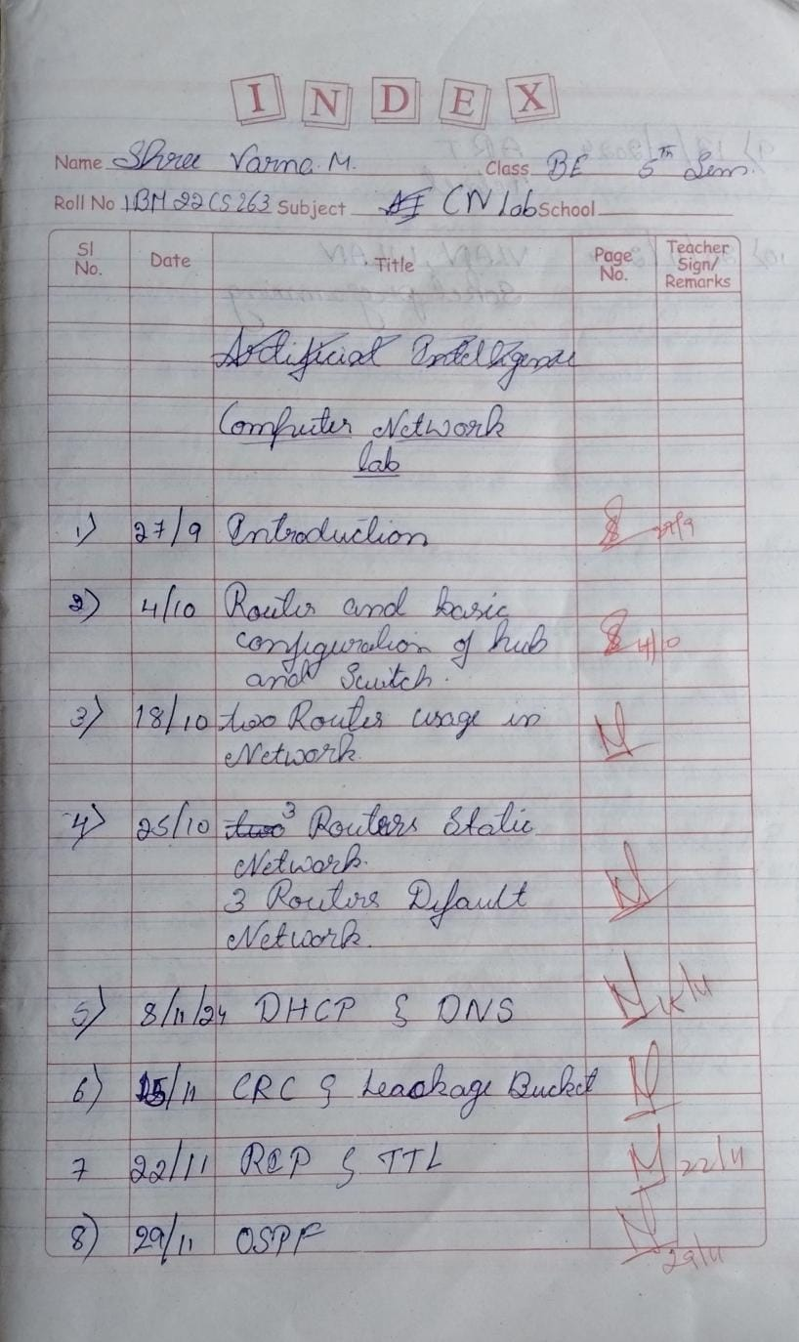

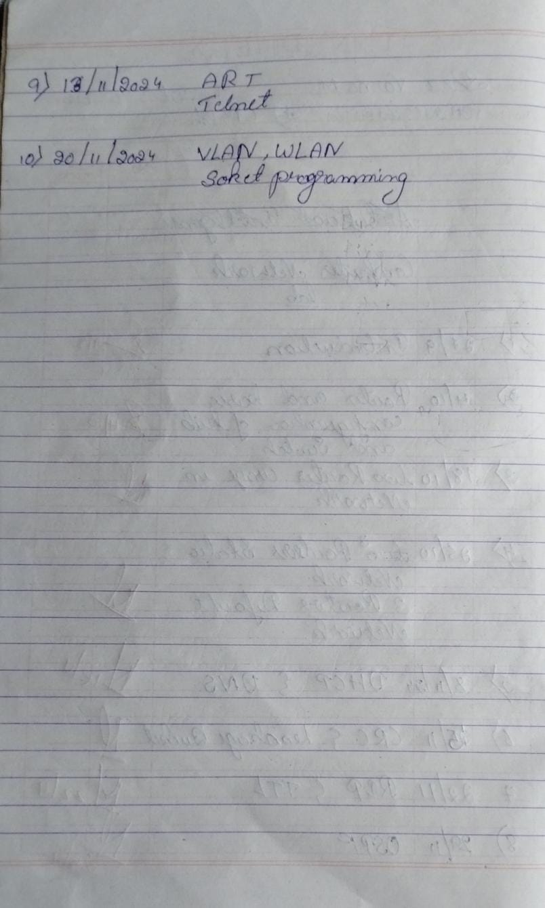

**Cycle-I**

## Program 1

1. Create a topology involving multiple hubs and a switch connecting them to simulate with simple PDU.
2. Procedure along with the topology

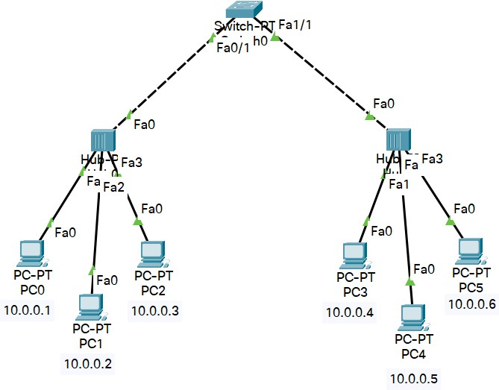

1. Screen shots/ output

Hub behaviour at sending end

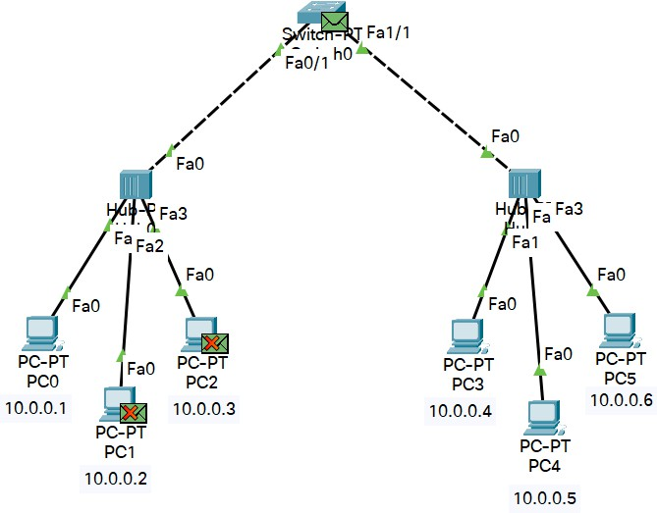

Switch behaviour

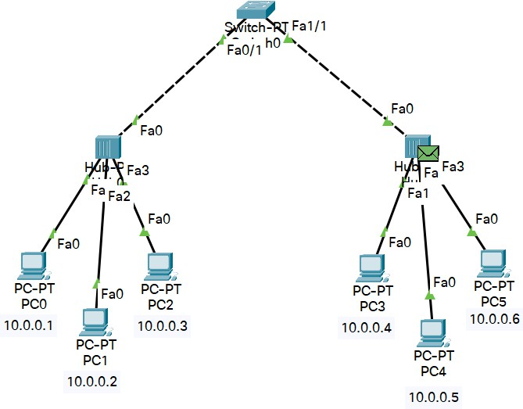

Hub behaviour at receiving end

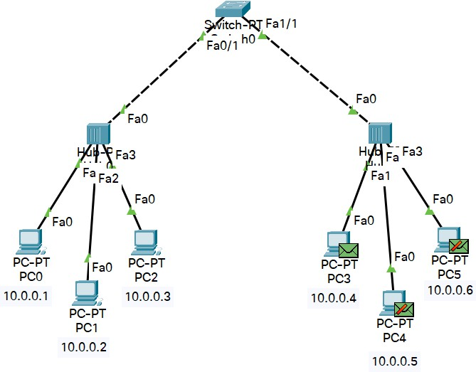

Hub behaviour when back to sender

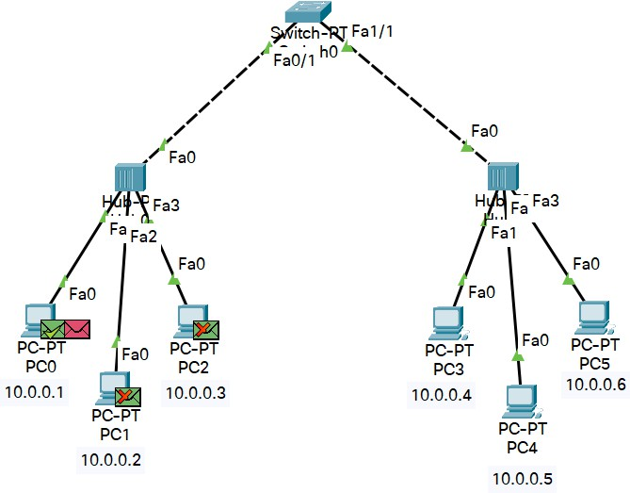

Ping command to connectivity

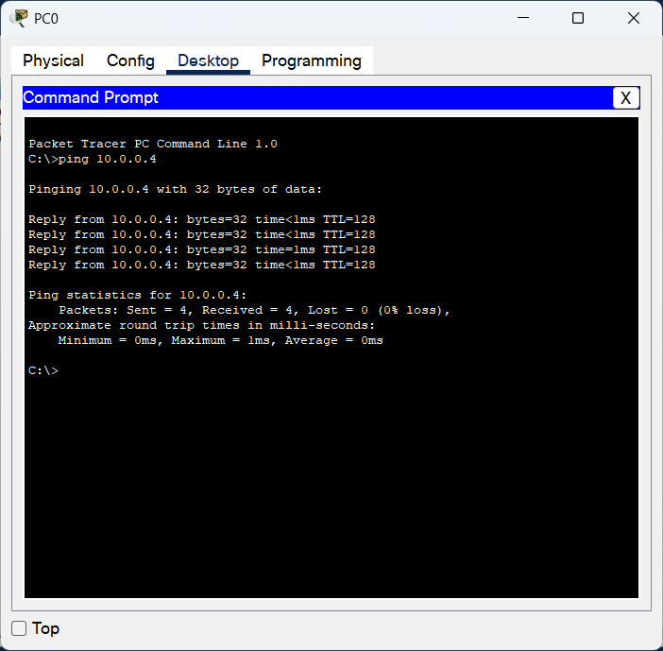

1. Observation

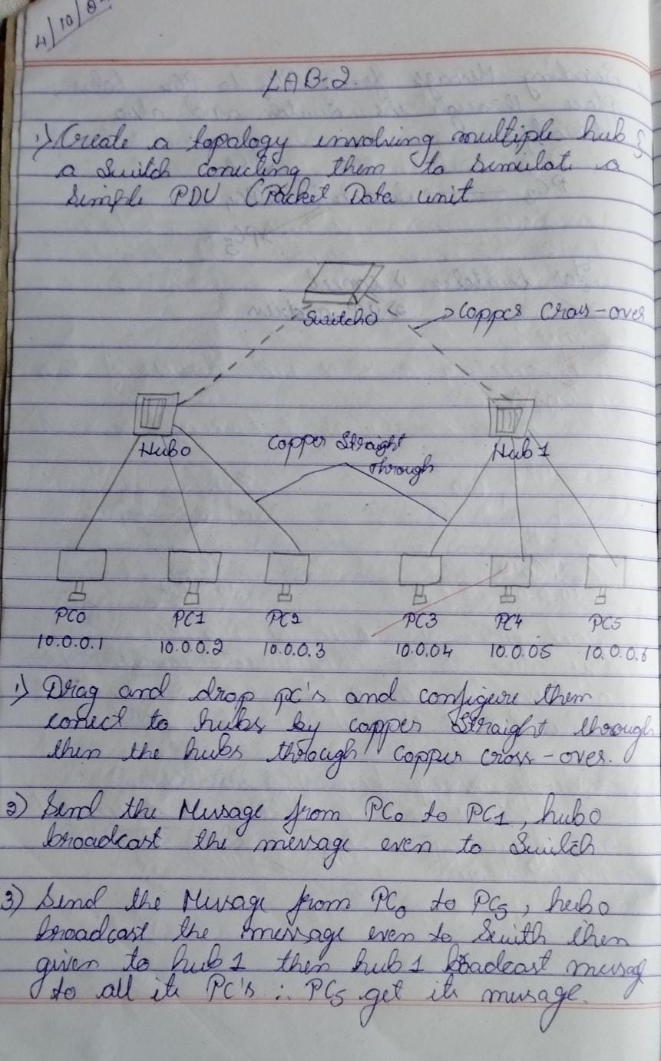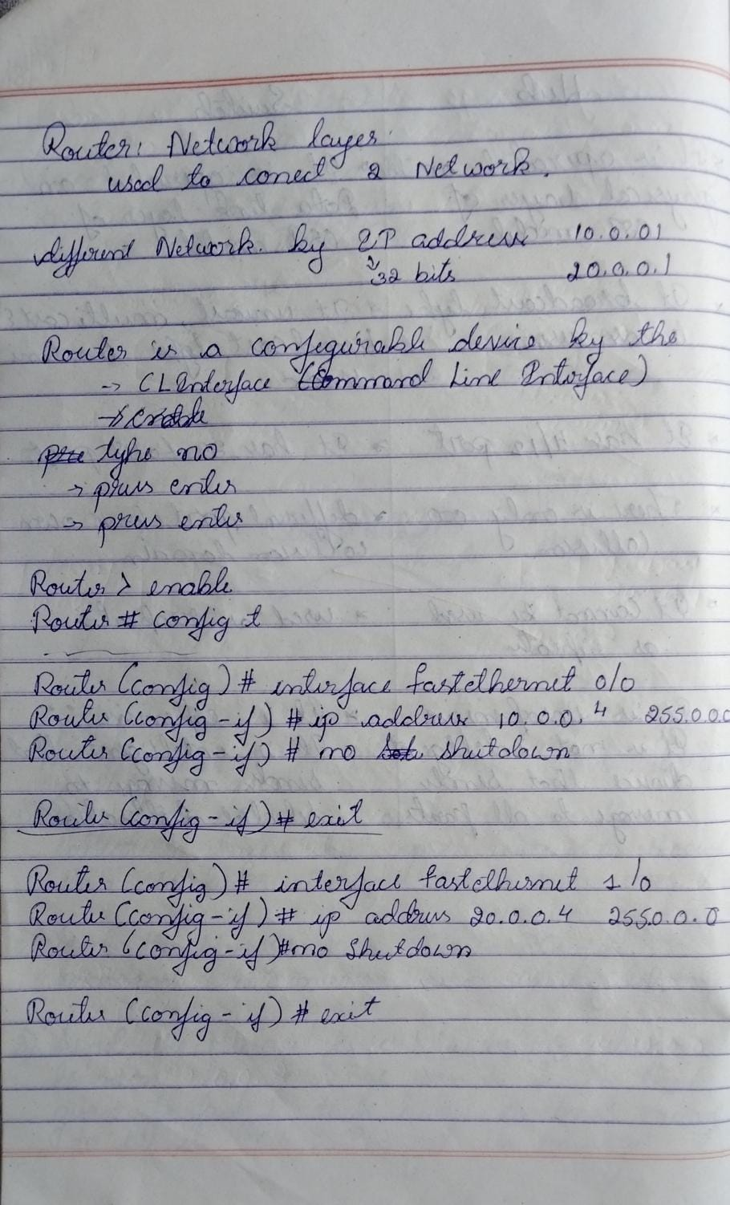

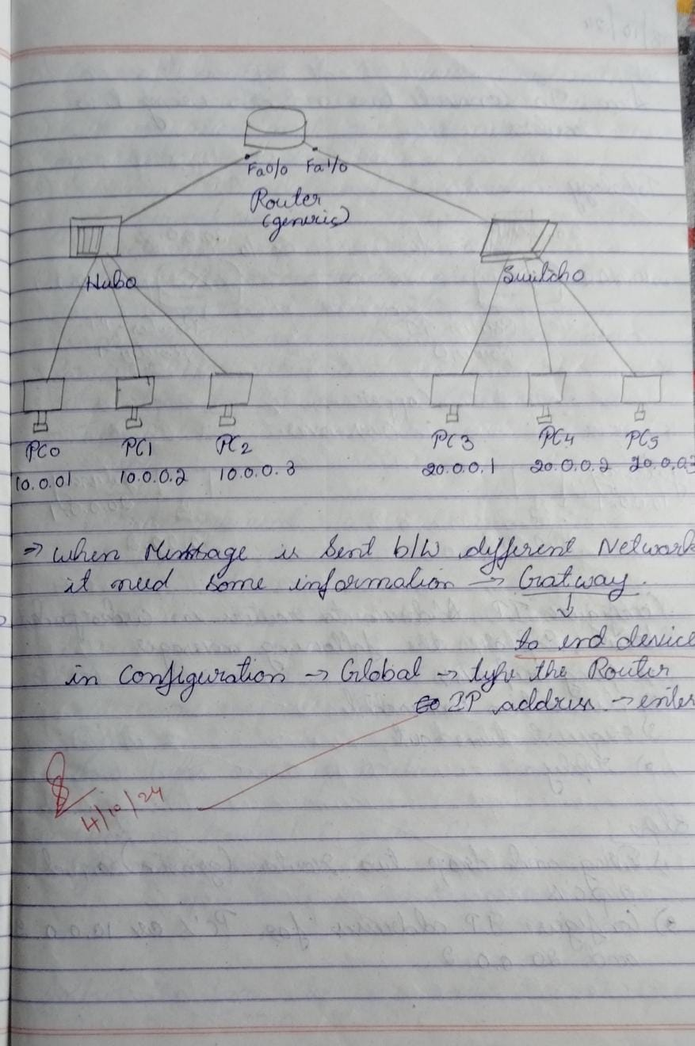

## Program 2

Configure IP address to routers in packet tracer. Explore the following messages: ping responses, destination unreachable, request timed out, reply

1. Procedure along with the topology

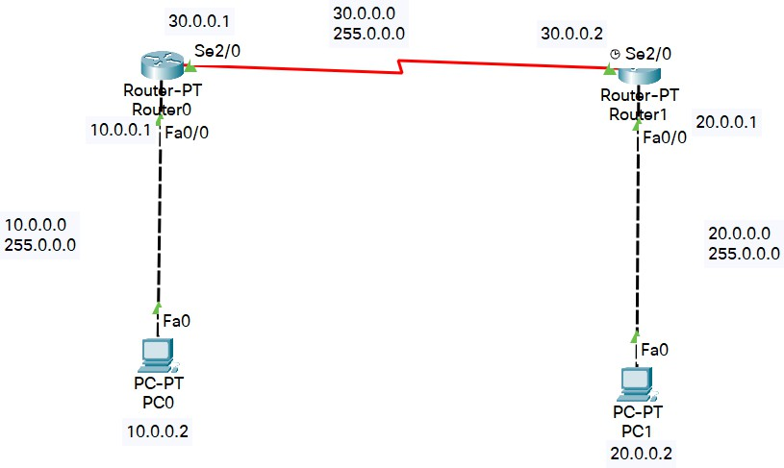

1. Screen shots/ output Router0 configuration

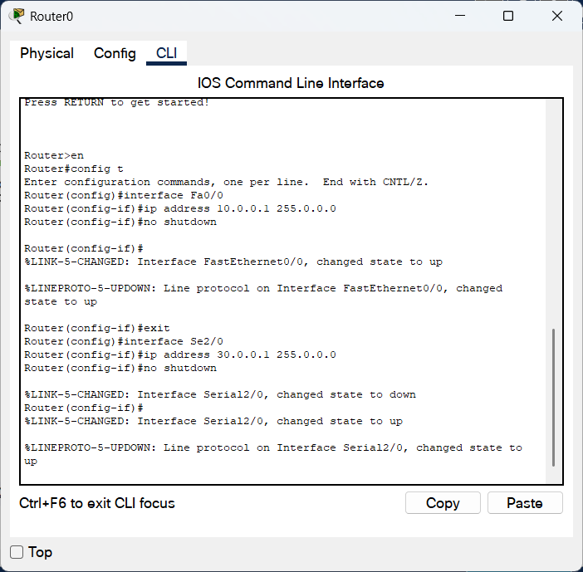

Router1 configuration

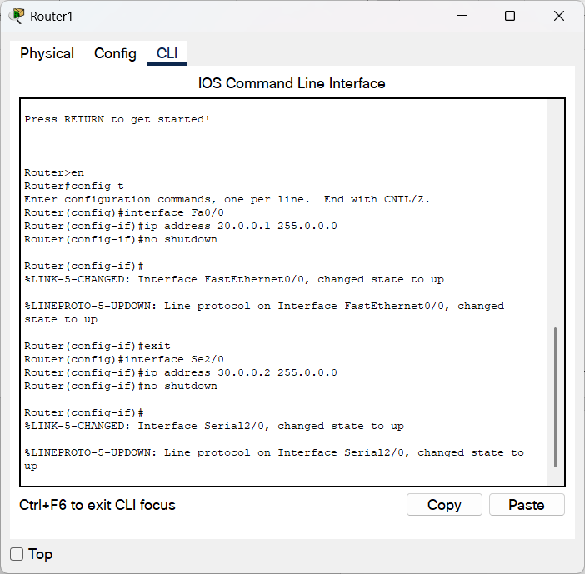

Ip route command in Router0

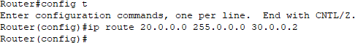

Ip route command in Router1

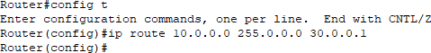

Destination host Unreachable (Before establishing network Fully)

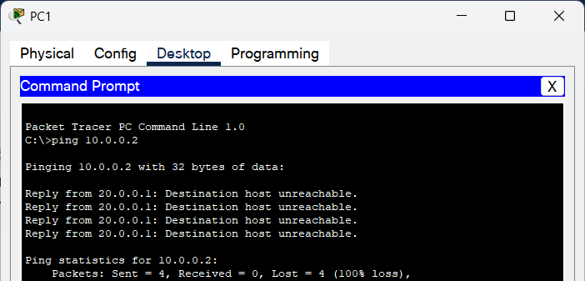

Request Timed Out

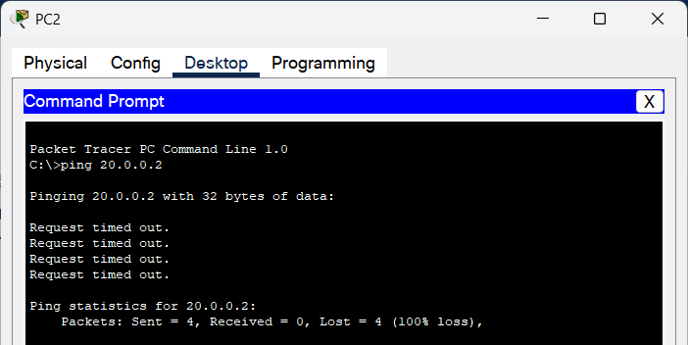

Reply from Destination

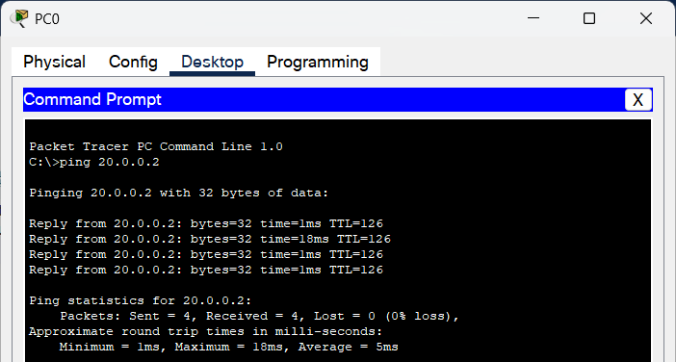

1. Observation

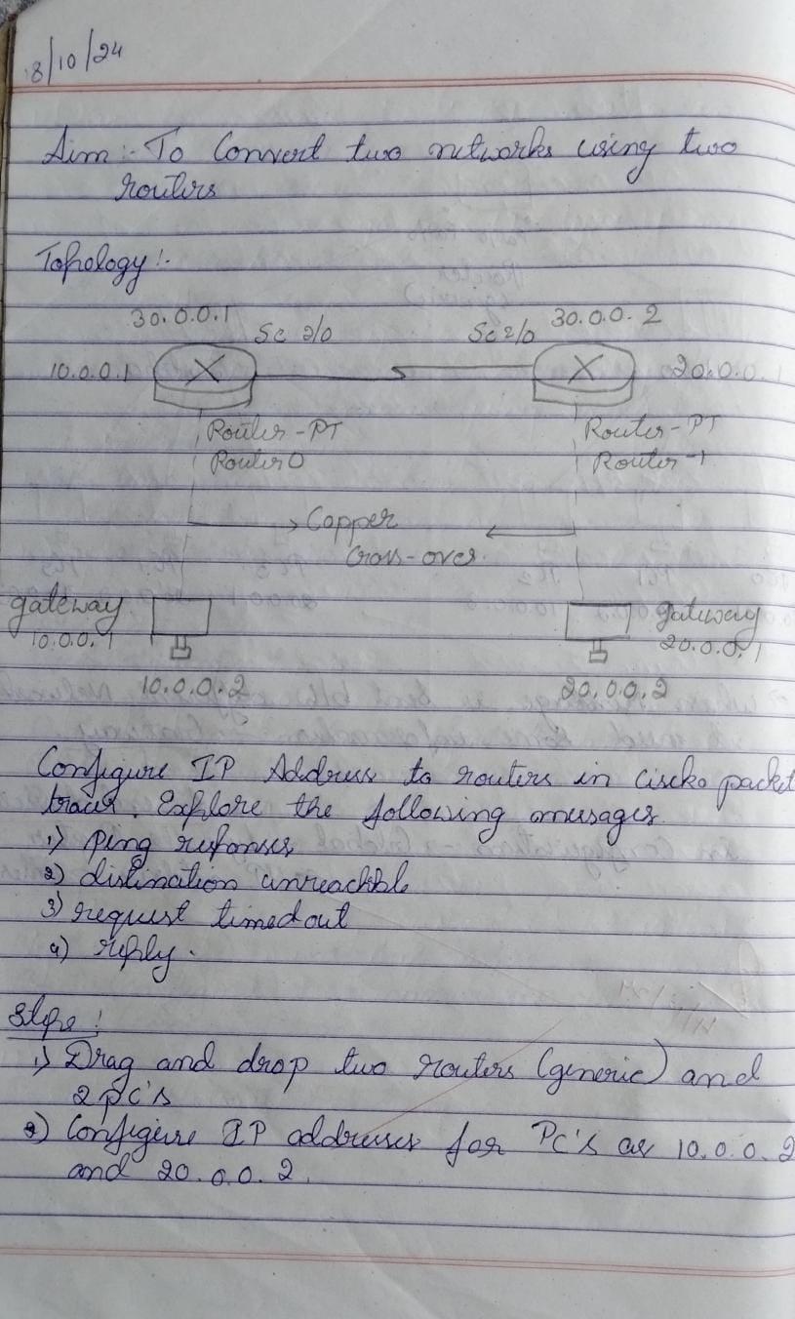

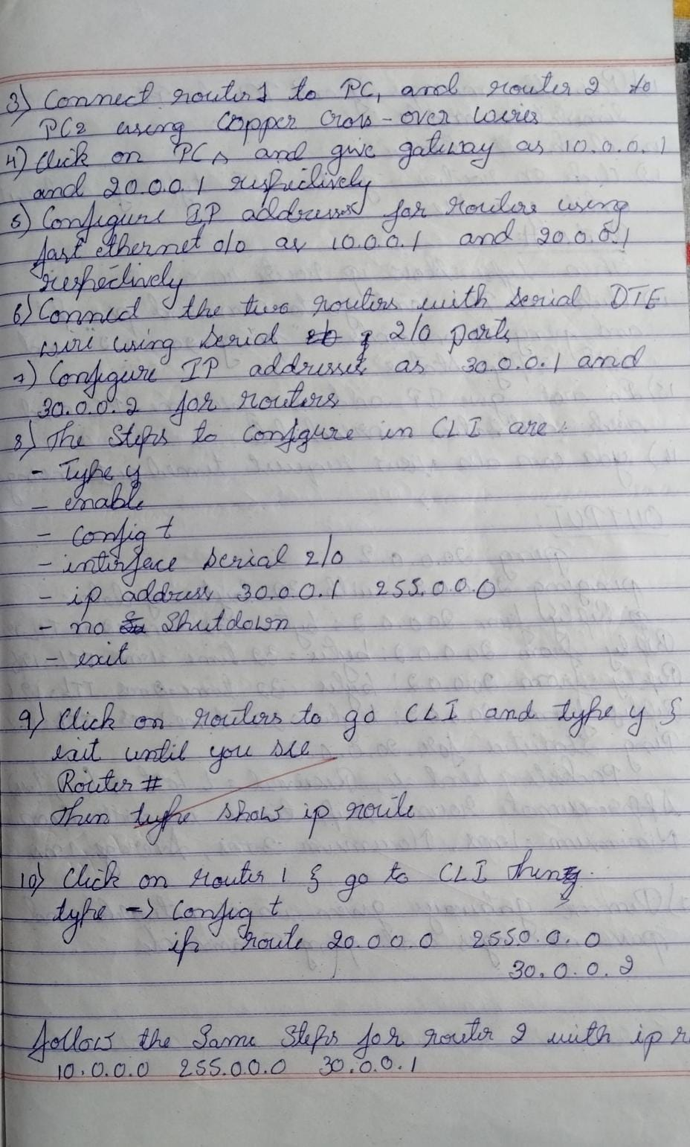

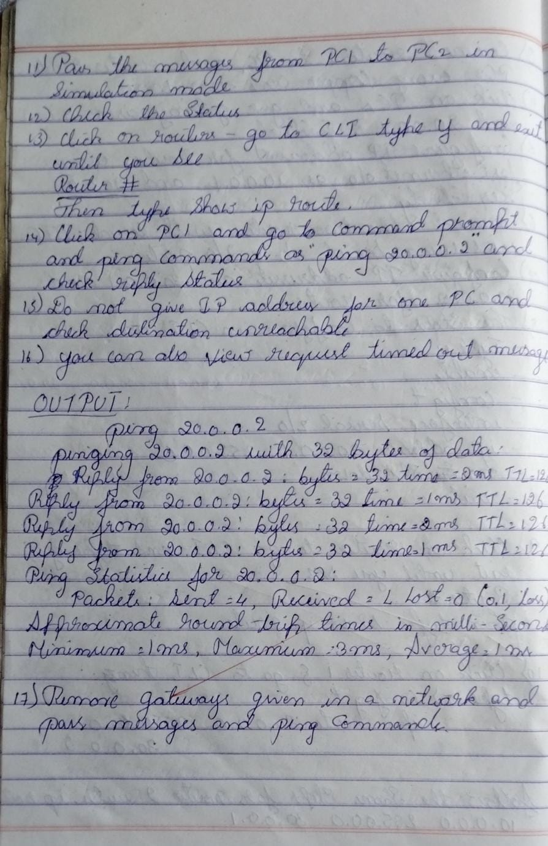

## Program 3

1. Configure default route, static route to the router
2. 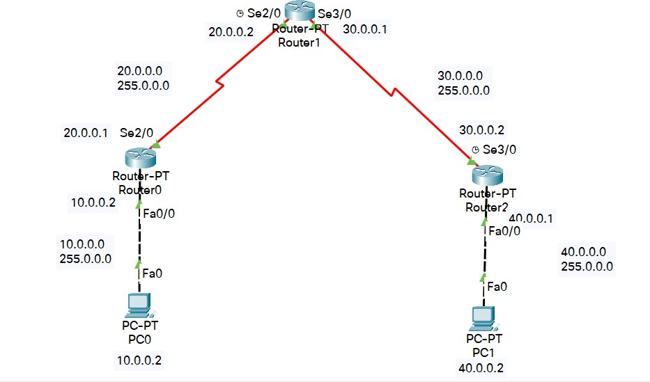Procedure along with the topology
3. Screen shots/ output Router0 configuration

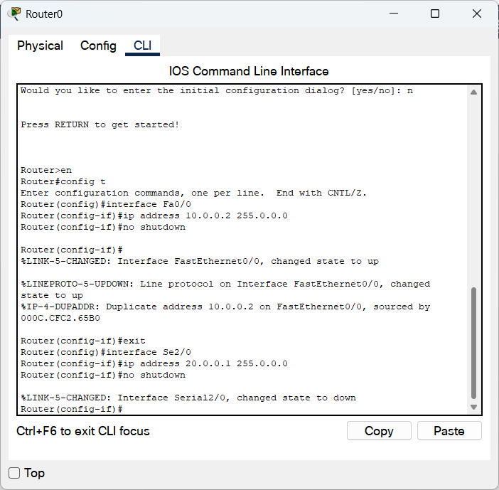

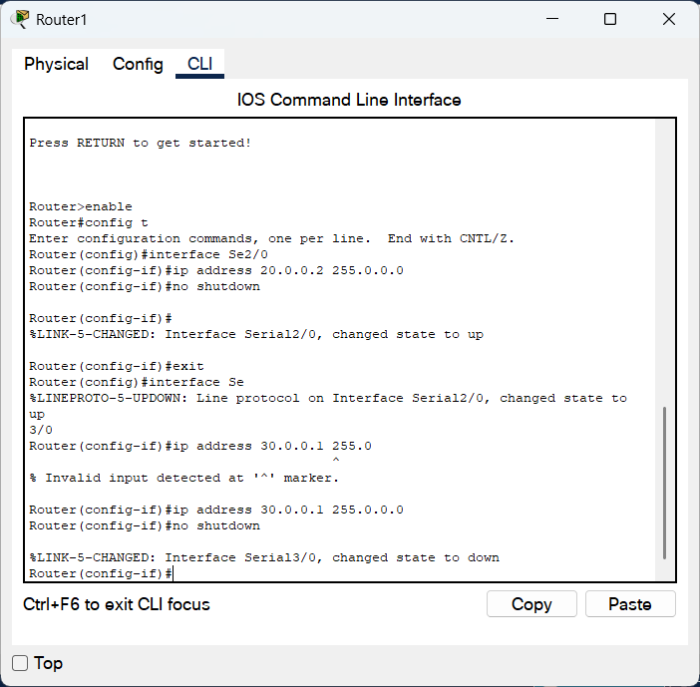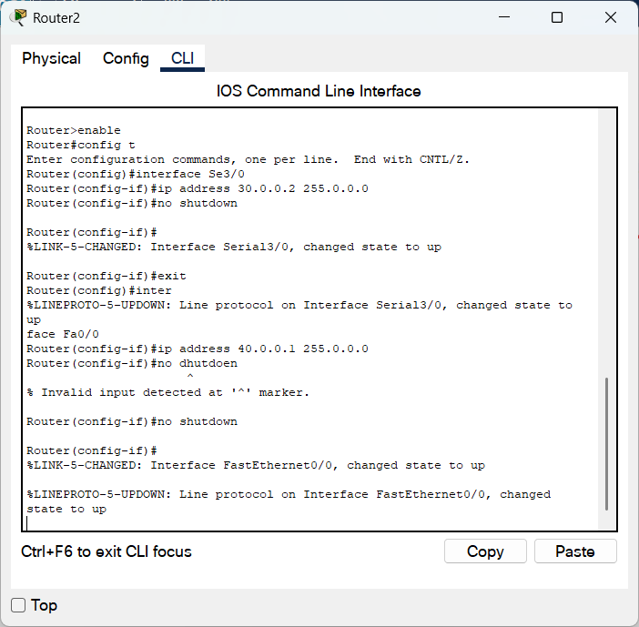Router1 configuration Router2 configuration

Static Routing:

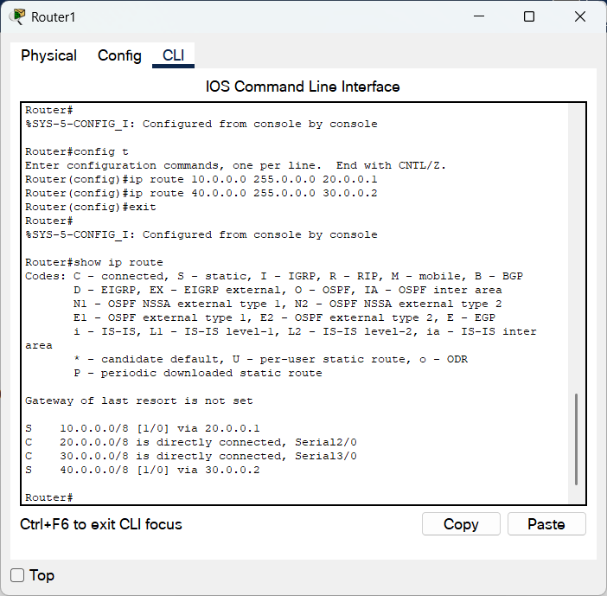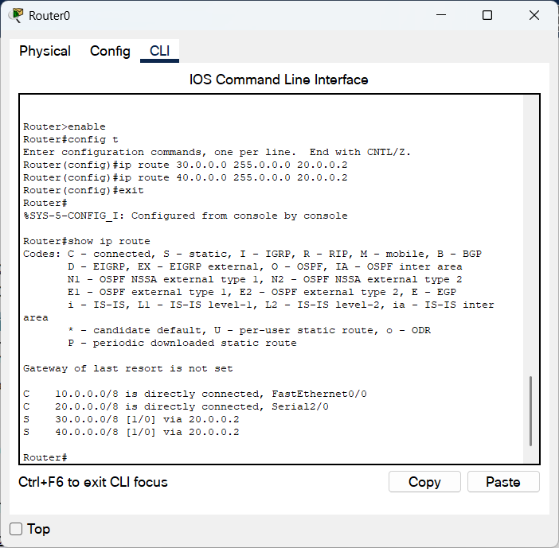

Router2

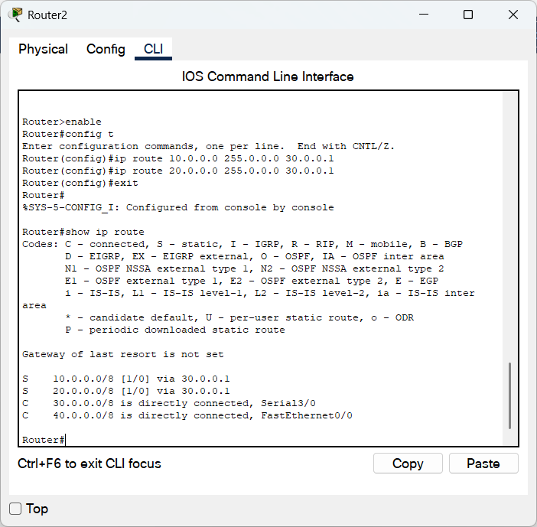

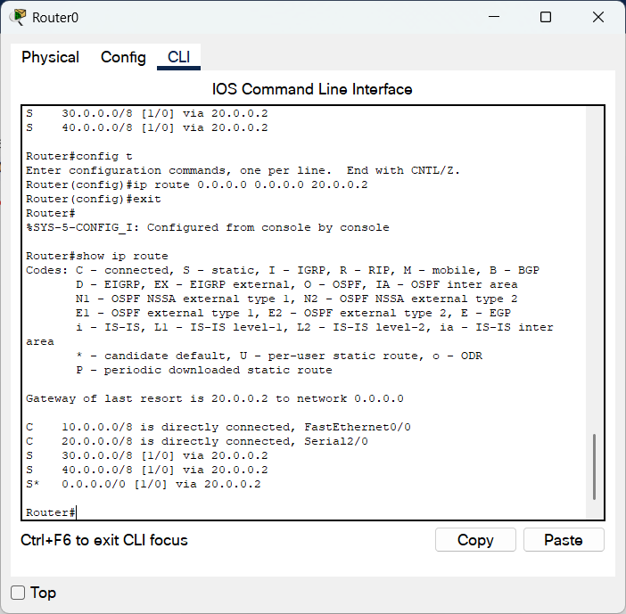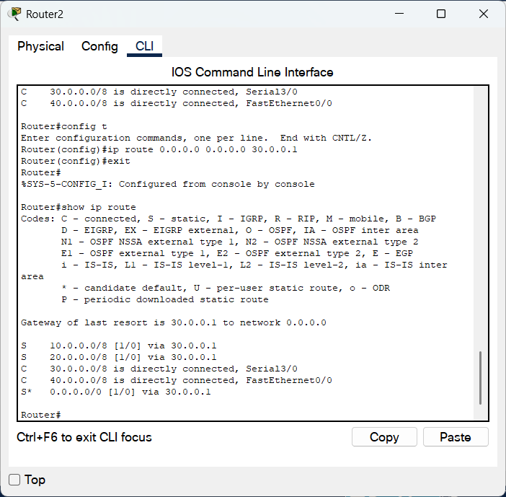Dynamic Routing:

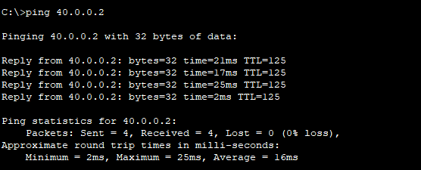 Pinging:

Observation:

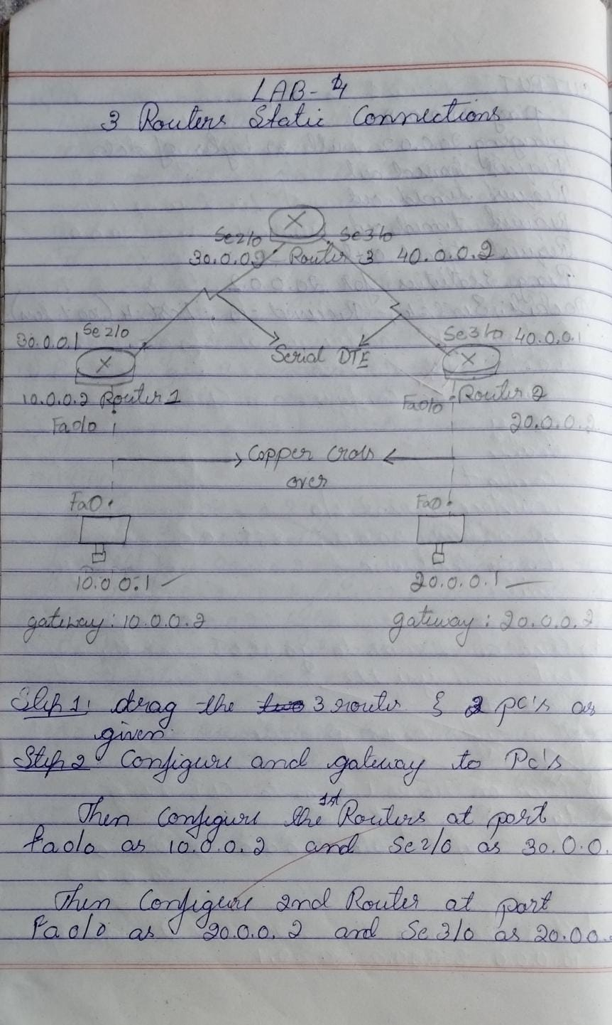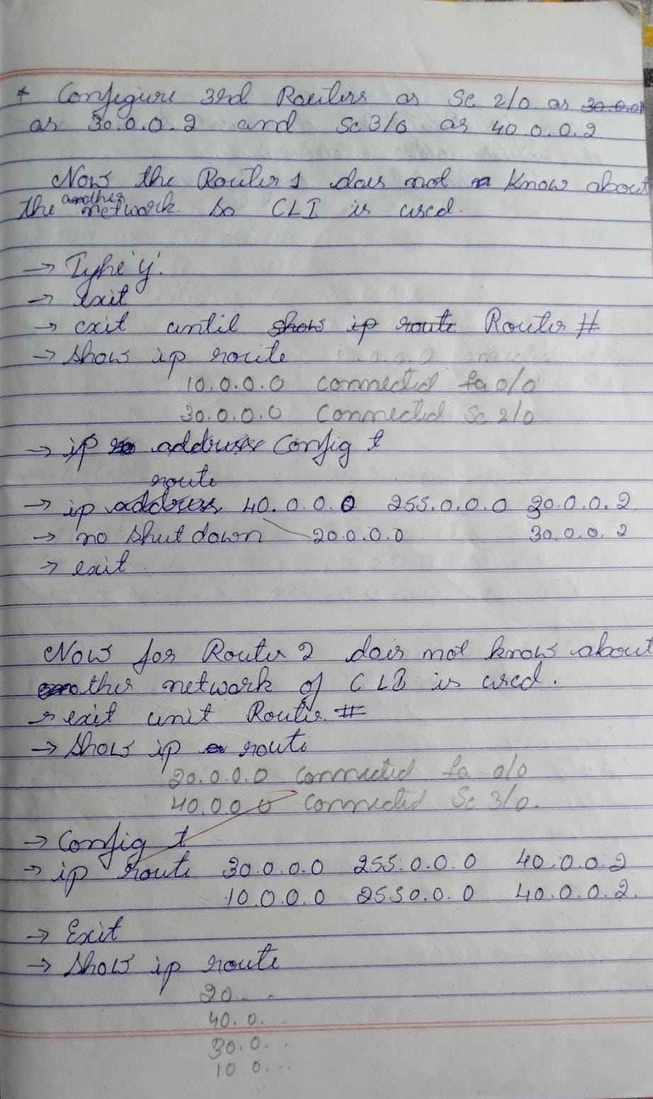

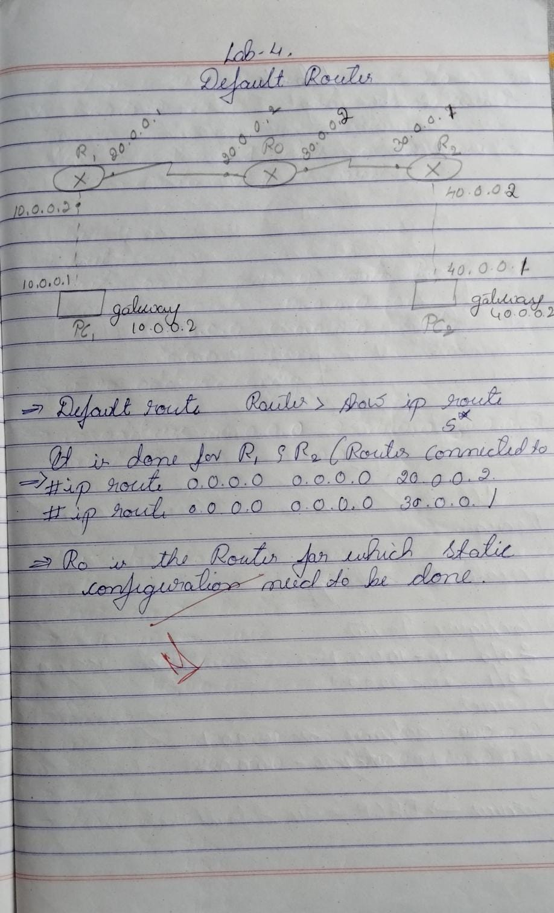

## Program 4

1. Configure DHCP within a LAN and outside LAN.
2. Procedure along with the topology

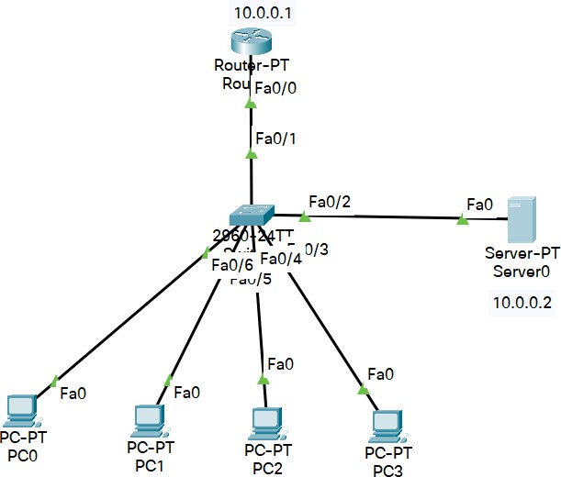

1. Screen shots/ output DHCP Within LAN

DHCP Configuration

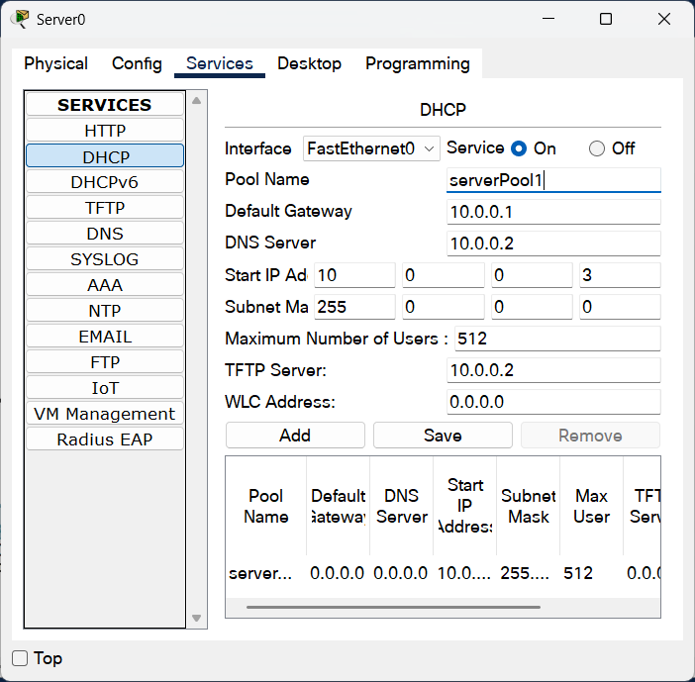

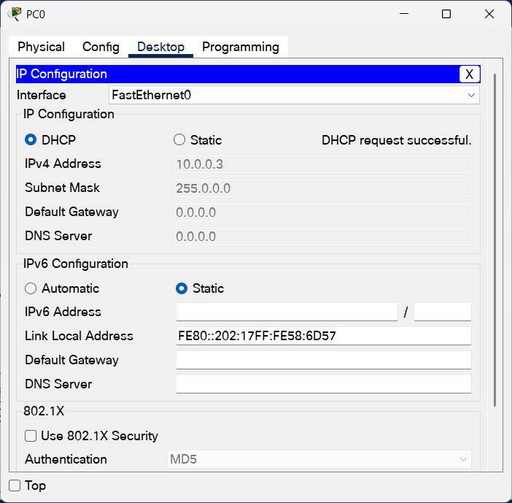PC settings

DHCP outside LAN:

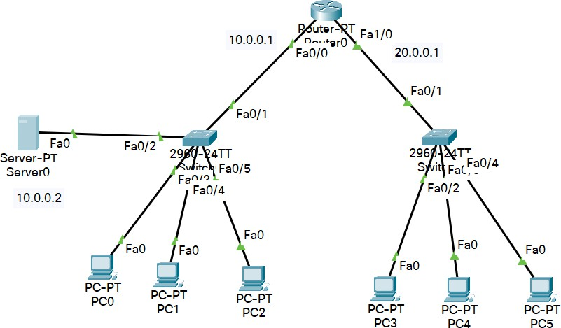

DHCP configuration for inside LAN

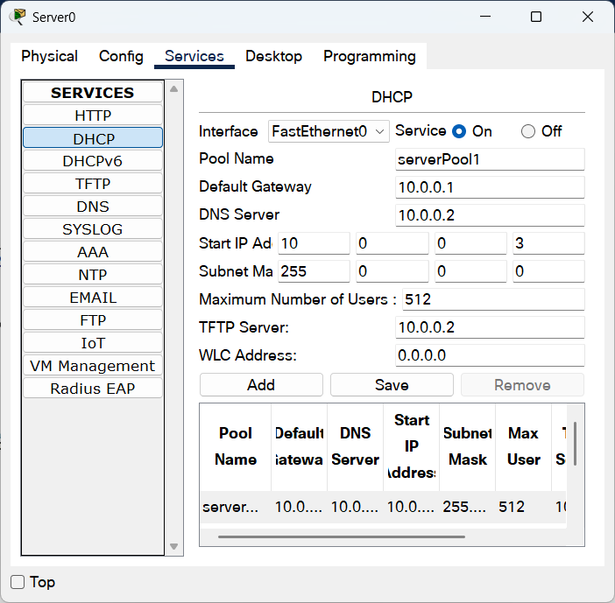

DHCP configuration for outside LAN

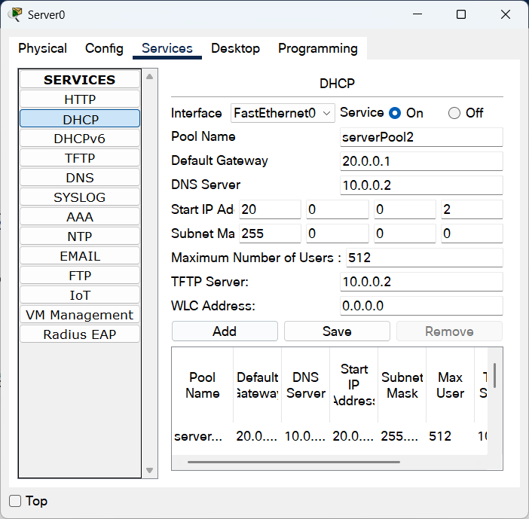

Ip helper command in Router

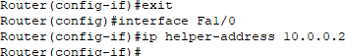

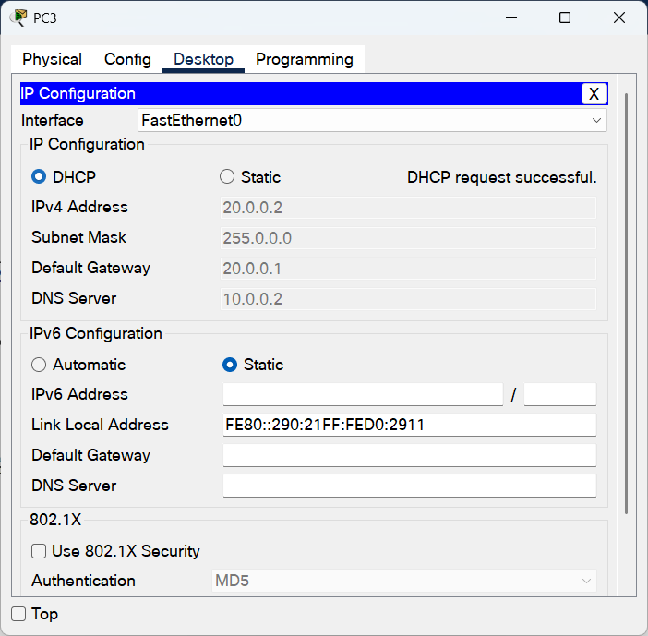PC setting in another network

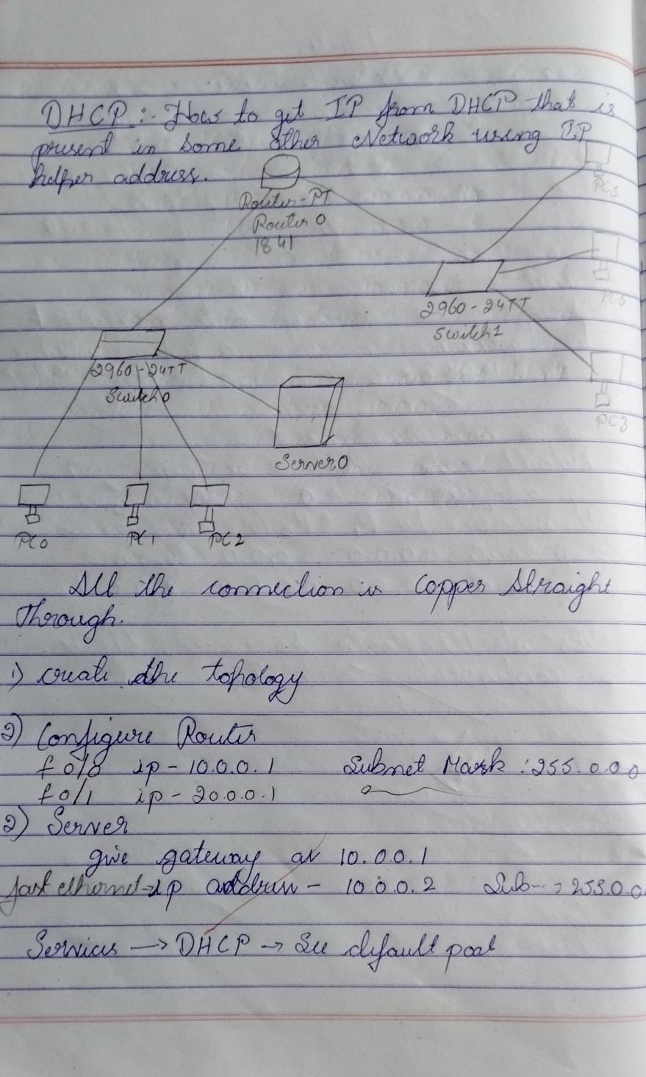observation

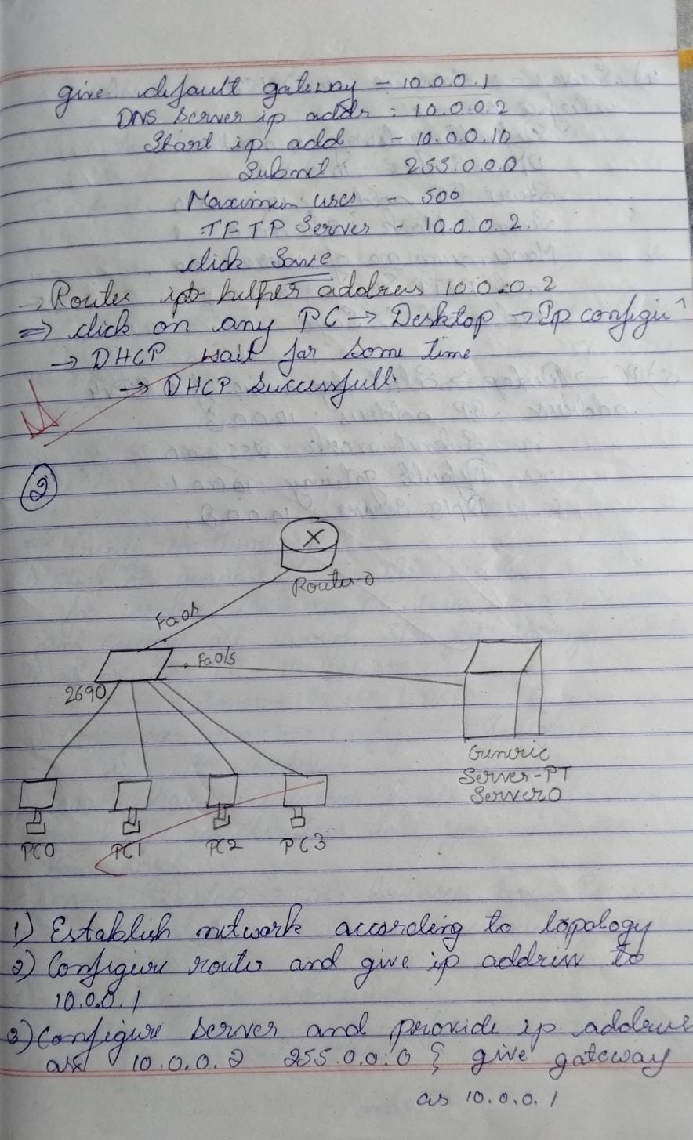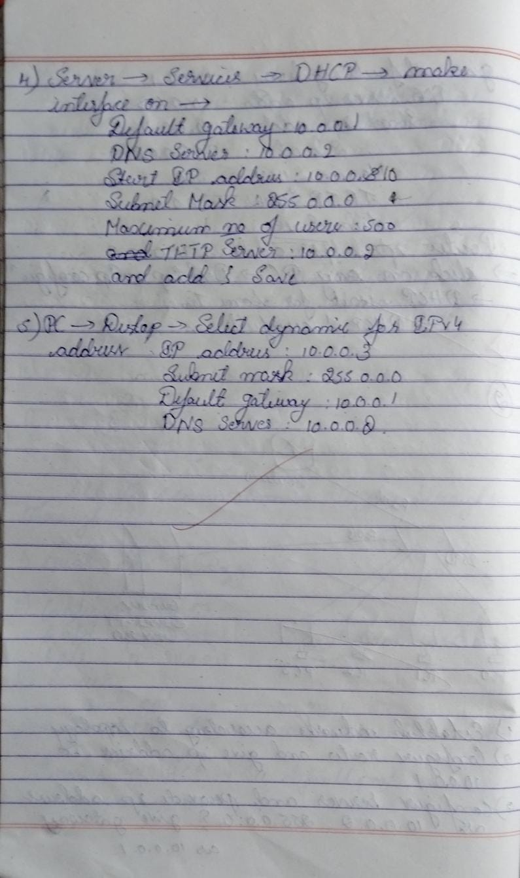

## Program 5

1. Configure RIP routing Protocol in Routers
2. Procedure along with the topology

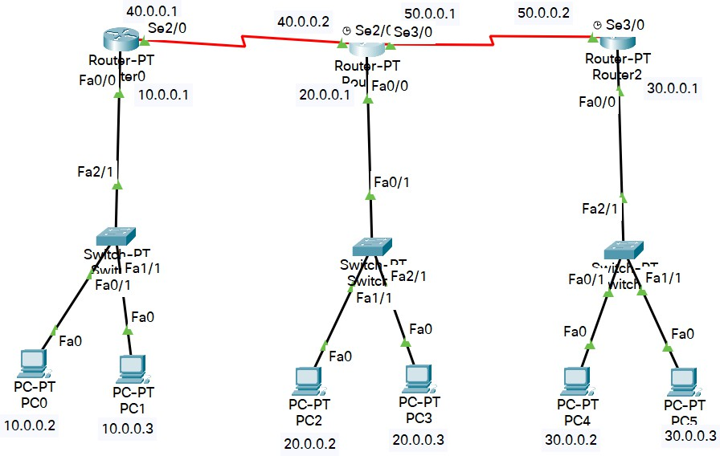

1. Screen shots/ output Router0

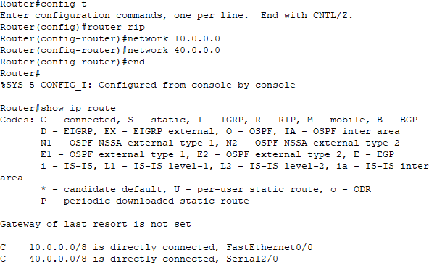

Router1

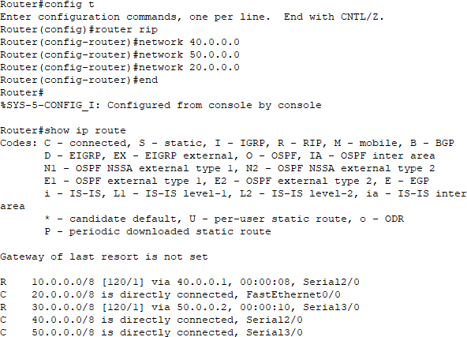

Router2

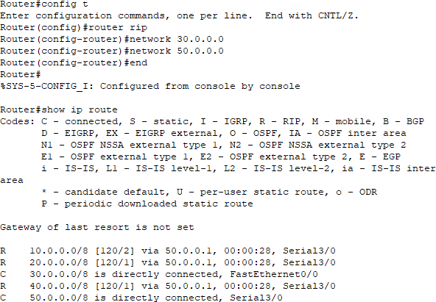

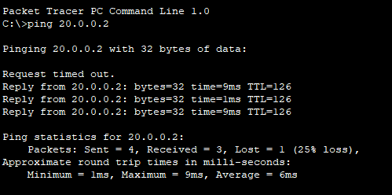Pinging:

1. Observation

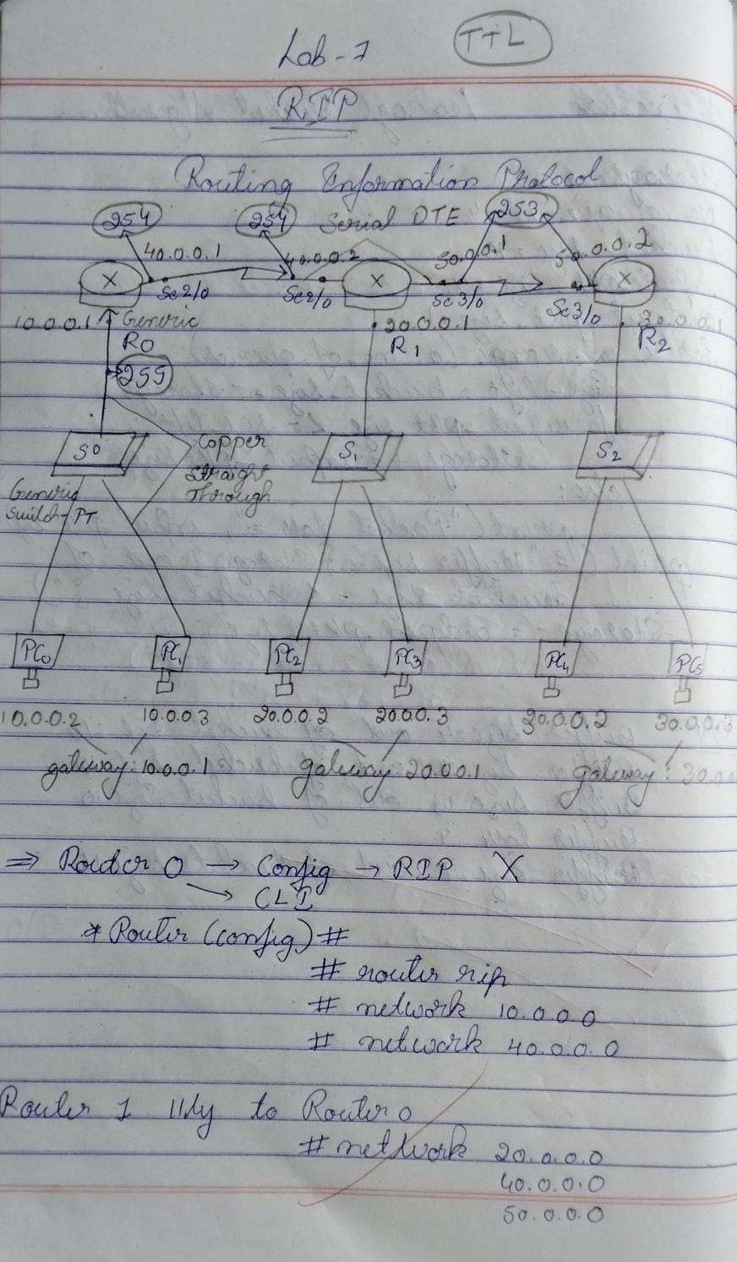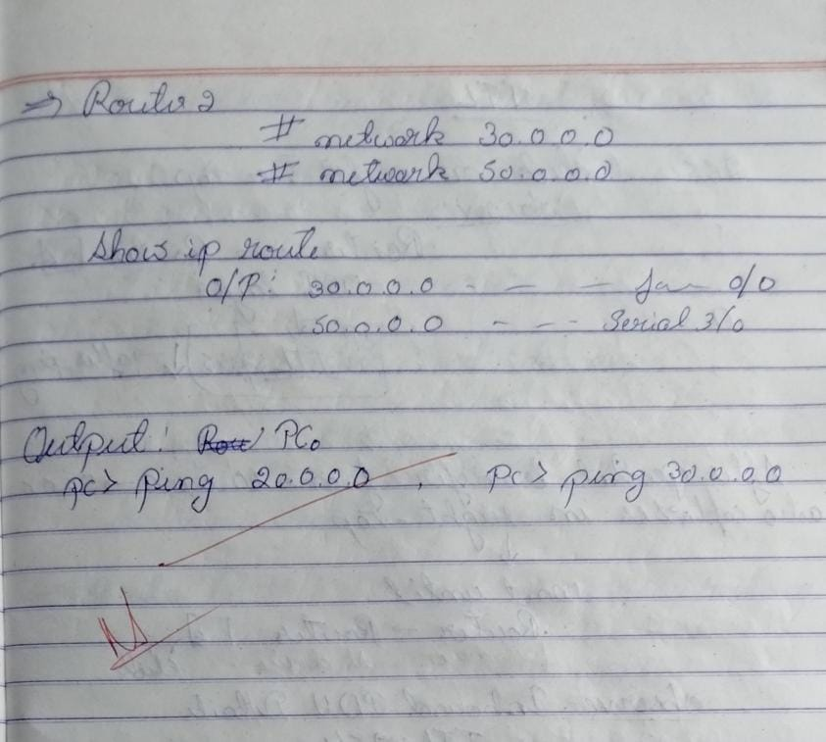

## Program 6

1. Configure OSPF routing protocol
2. Procedure along with the topology

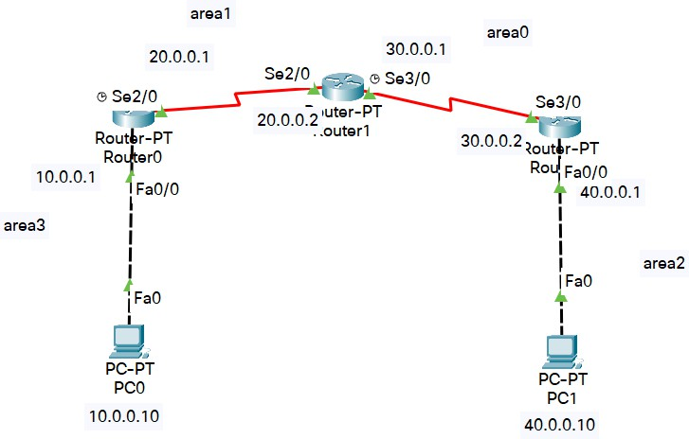

1. Screen shots/ output Encapsulation:

Router0

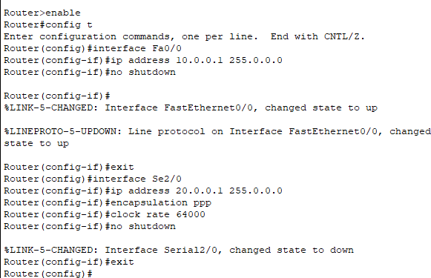

Router1

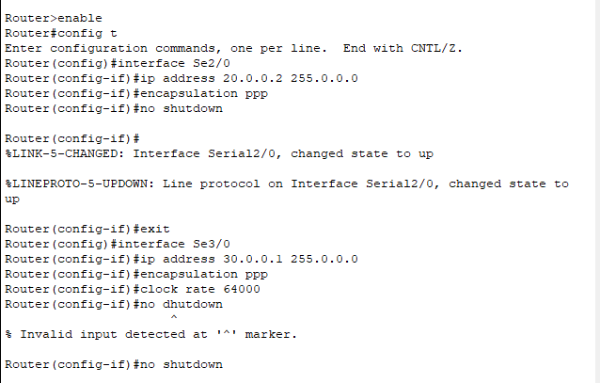

Router2

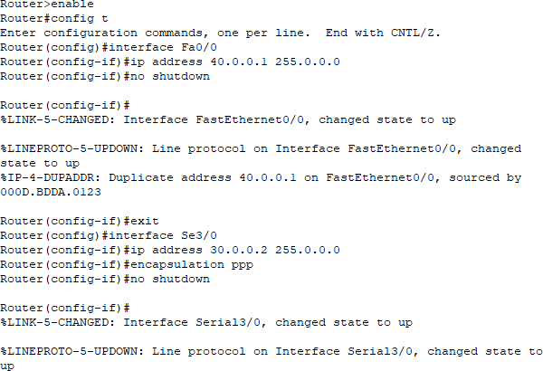

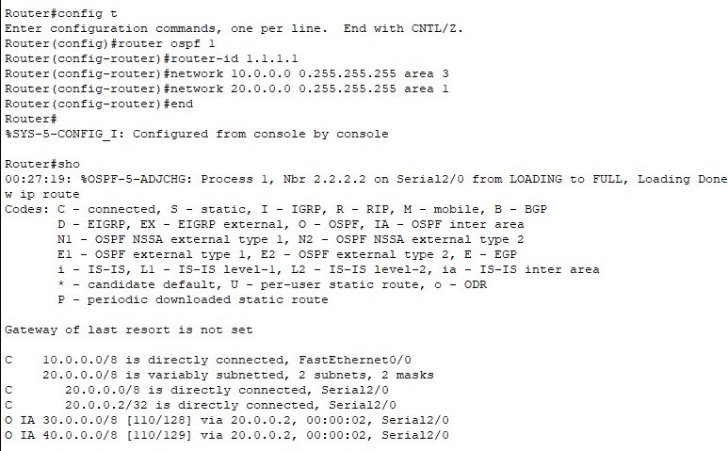OSPF Routing Protocol Router0

Router1

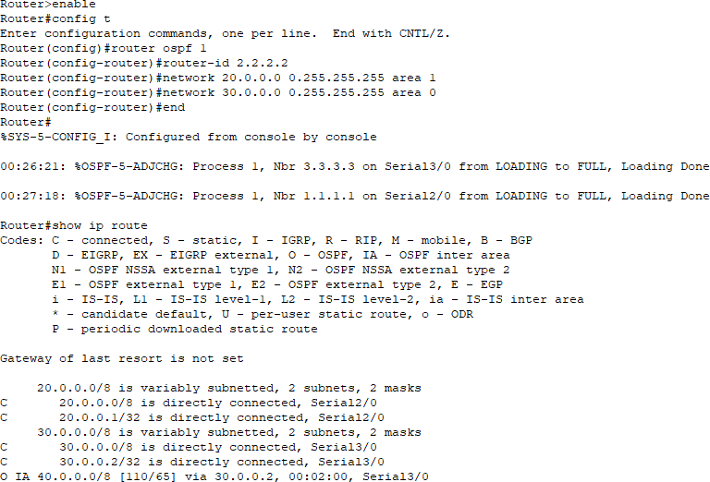

Router2

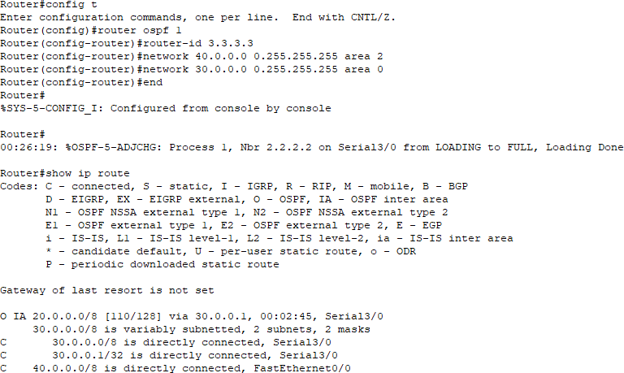

Configure Loopback address Router0

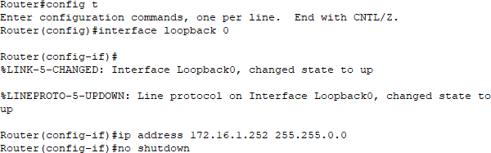

Router1

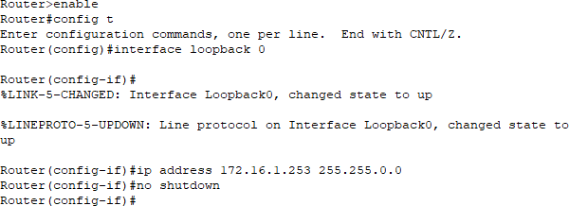

Router2

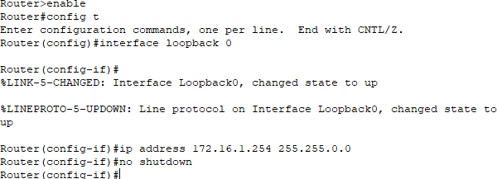

Create Virtual Link Router0

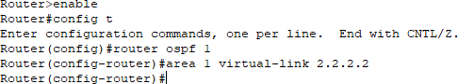

Router1

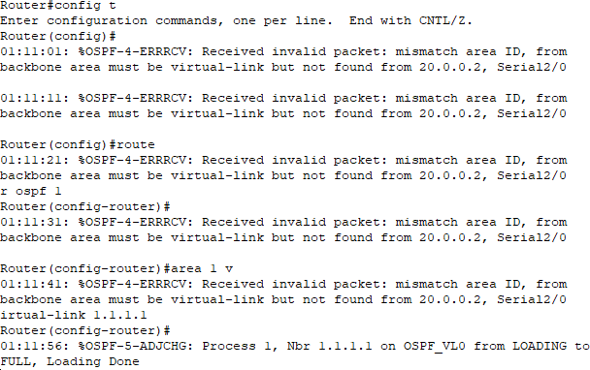

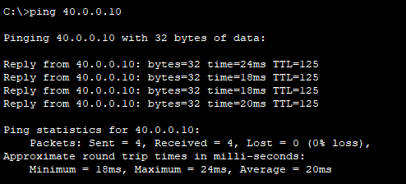Pinging

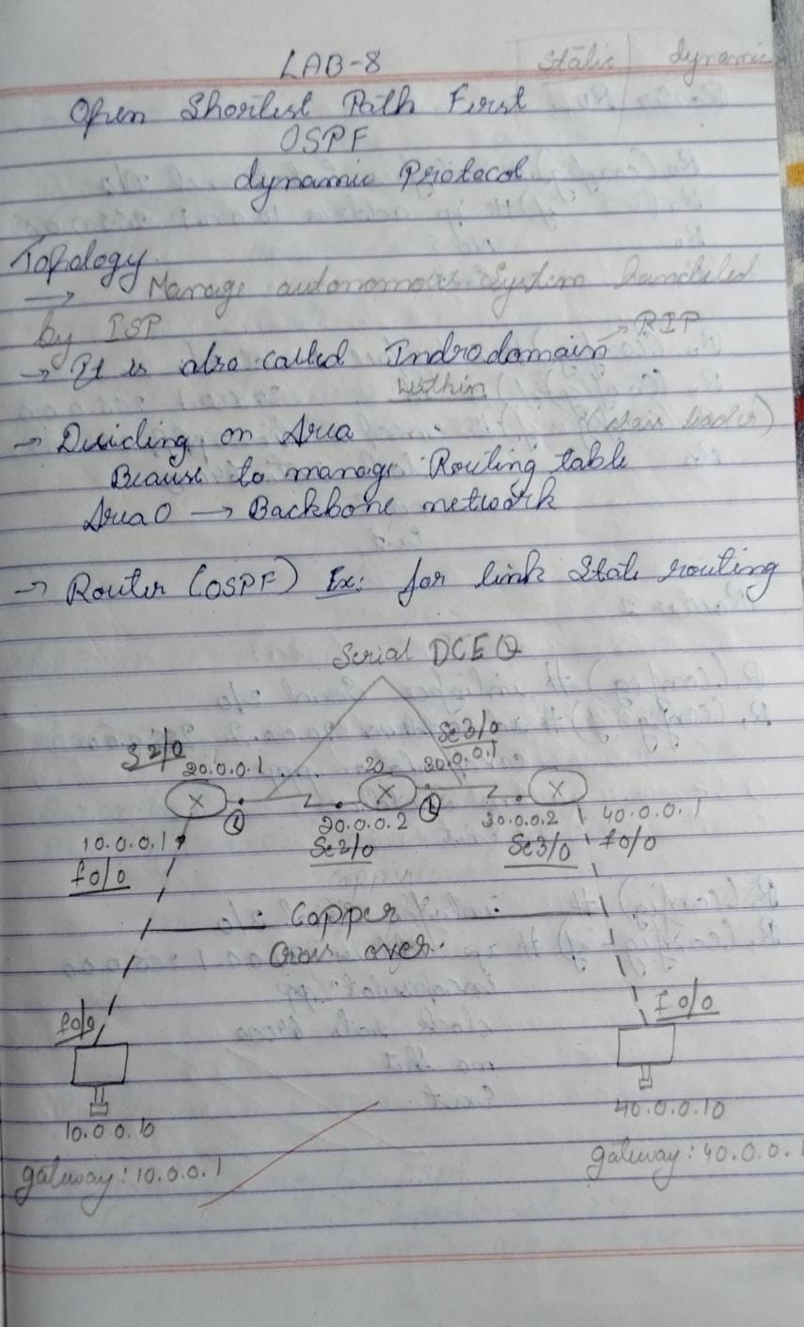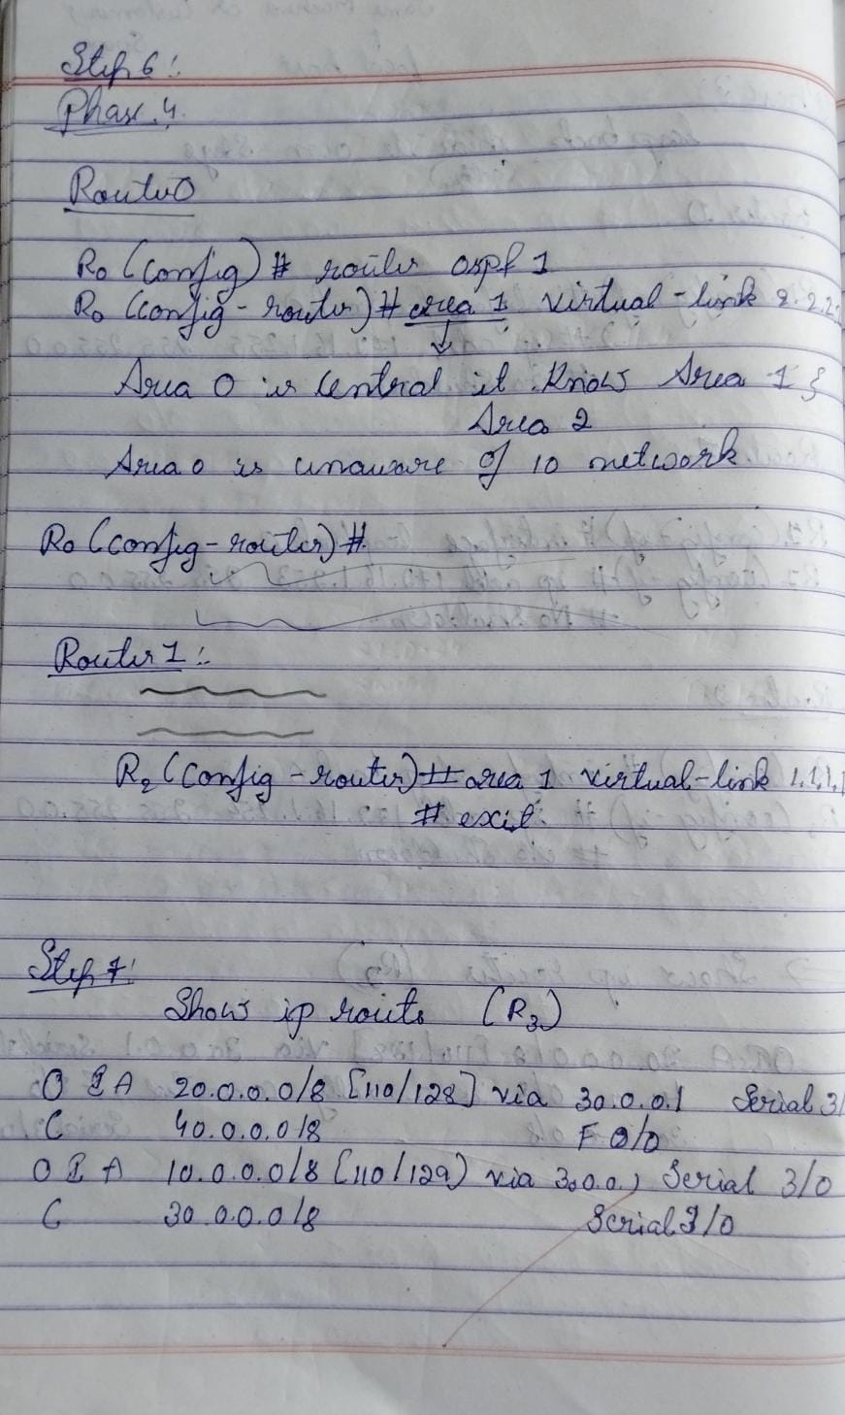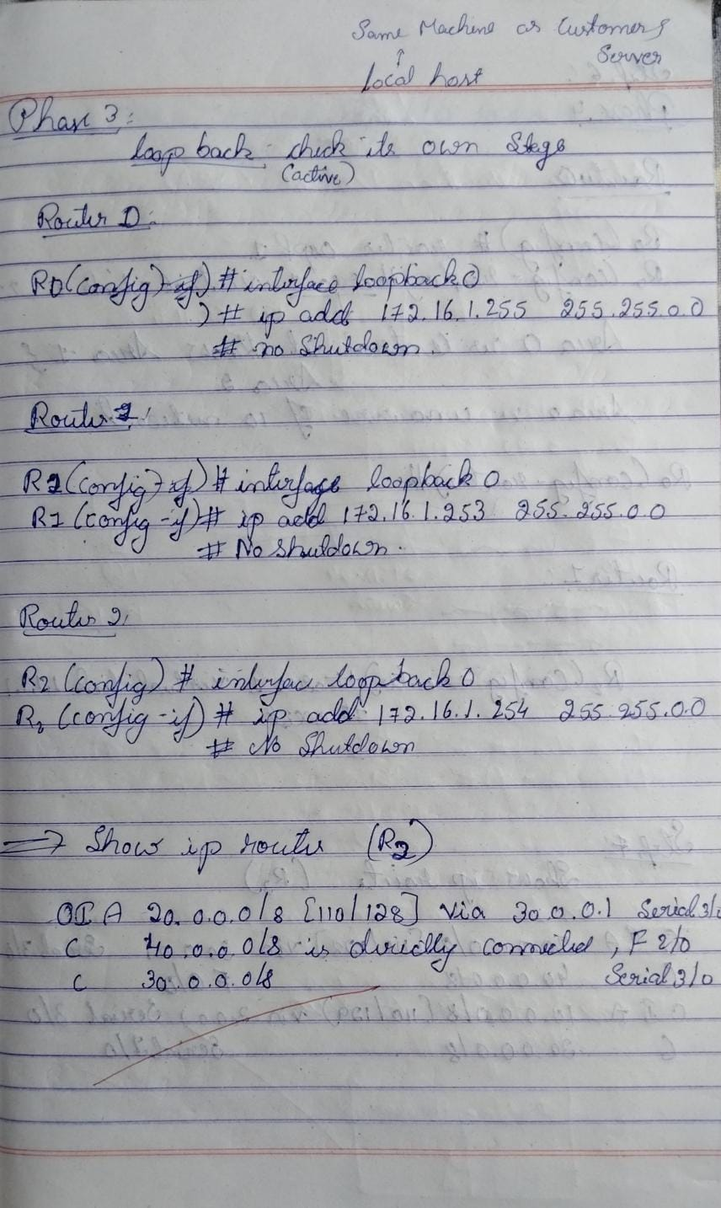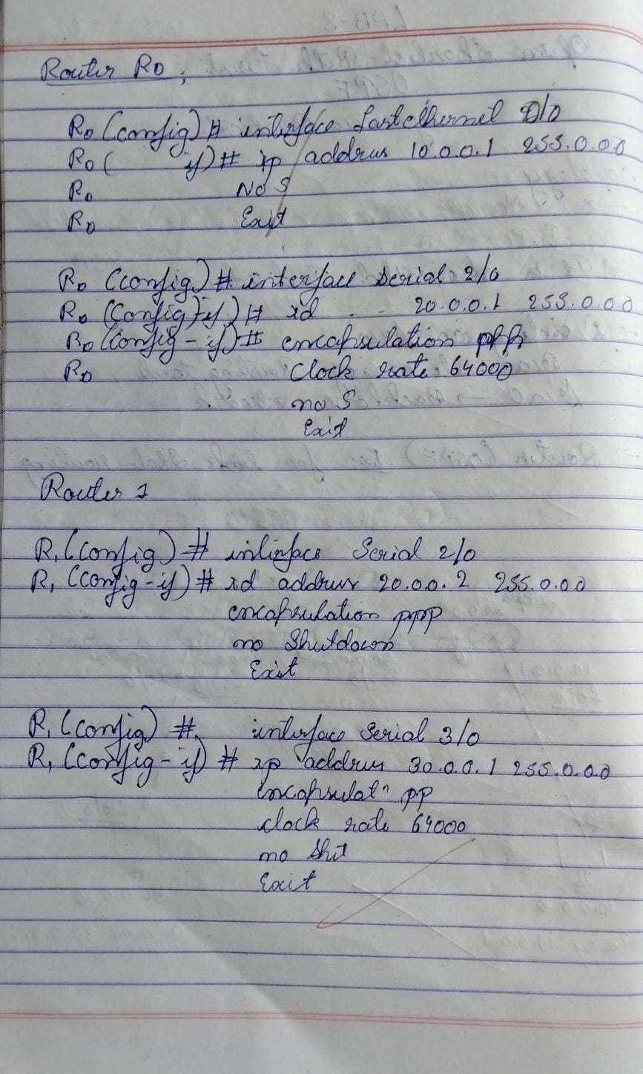Observation :

## Program 7

1. Demonstrate the TTL/ Life of a Packet
2. Procedure along with the topology

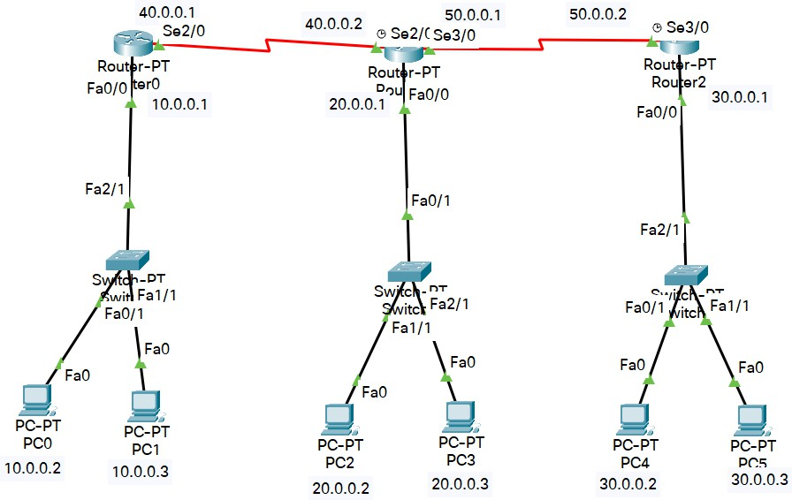

1. Screen shots/ output Packet at Router0

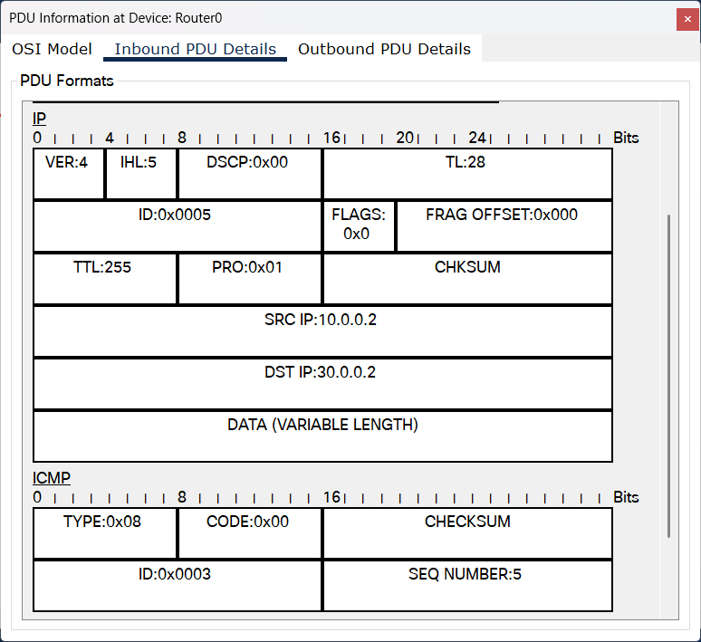 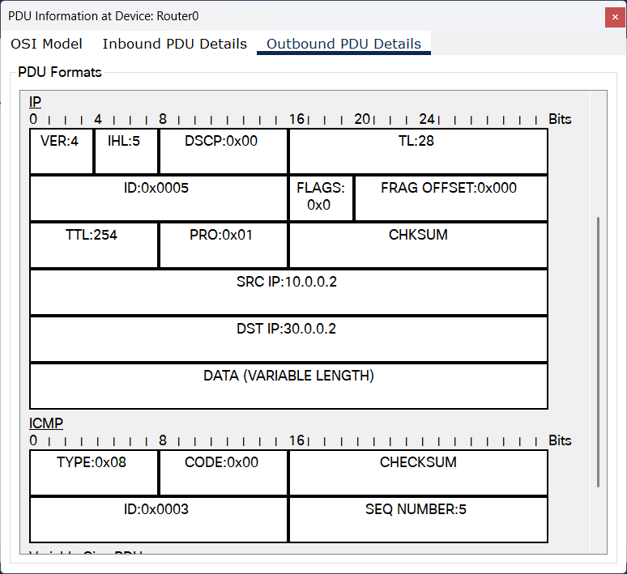

Packet at Router1

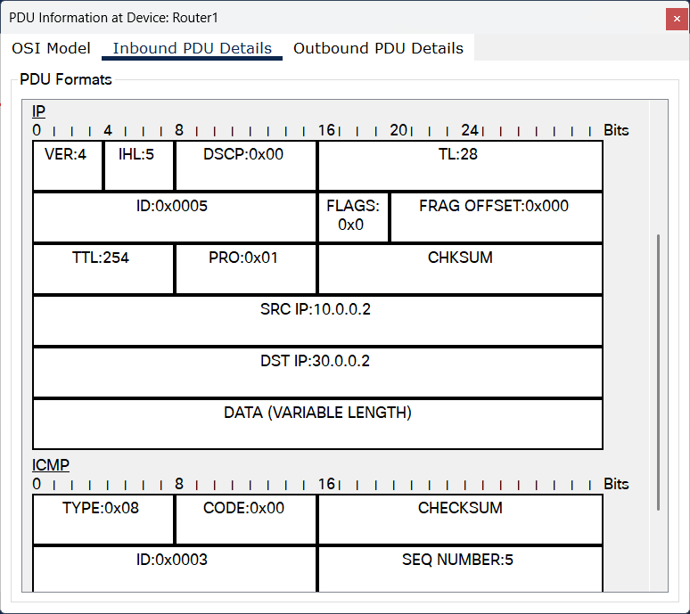 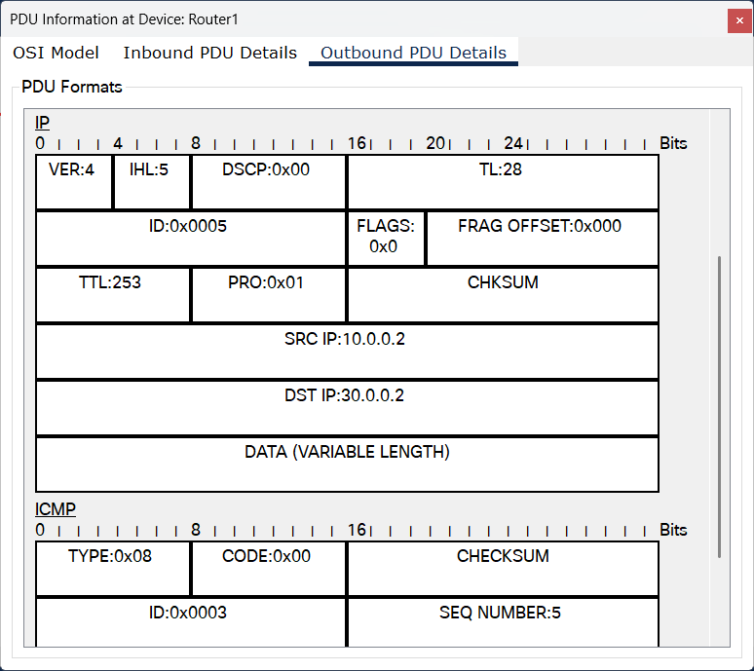

Packet at Router2

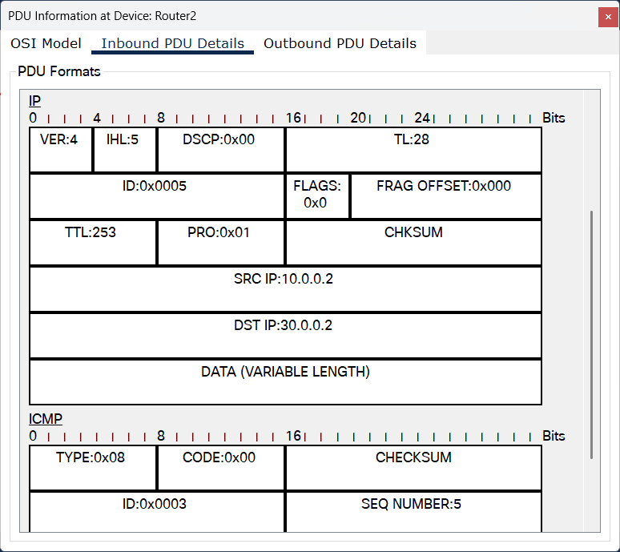 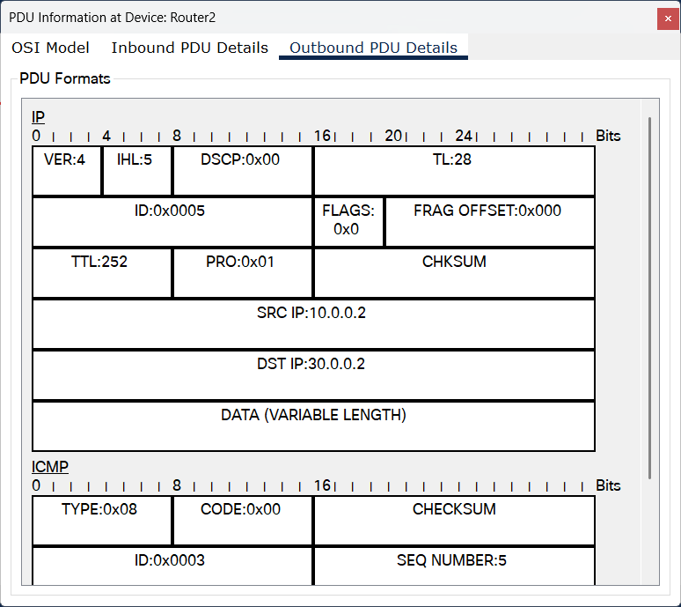

1. 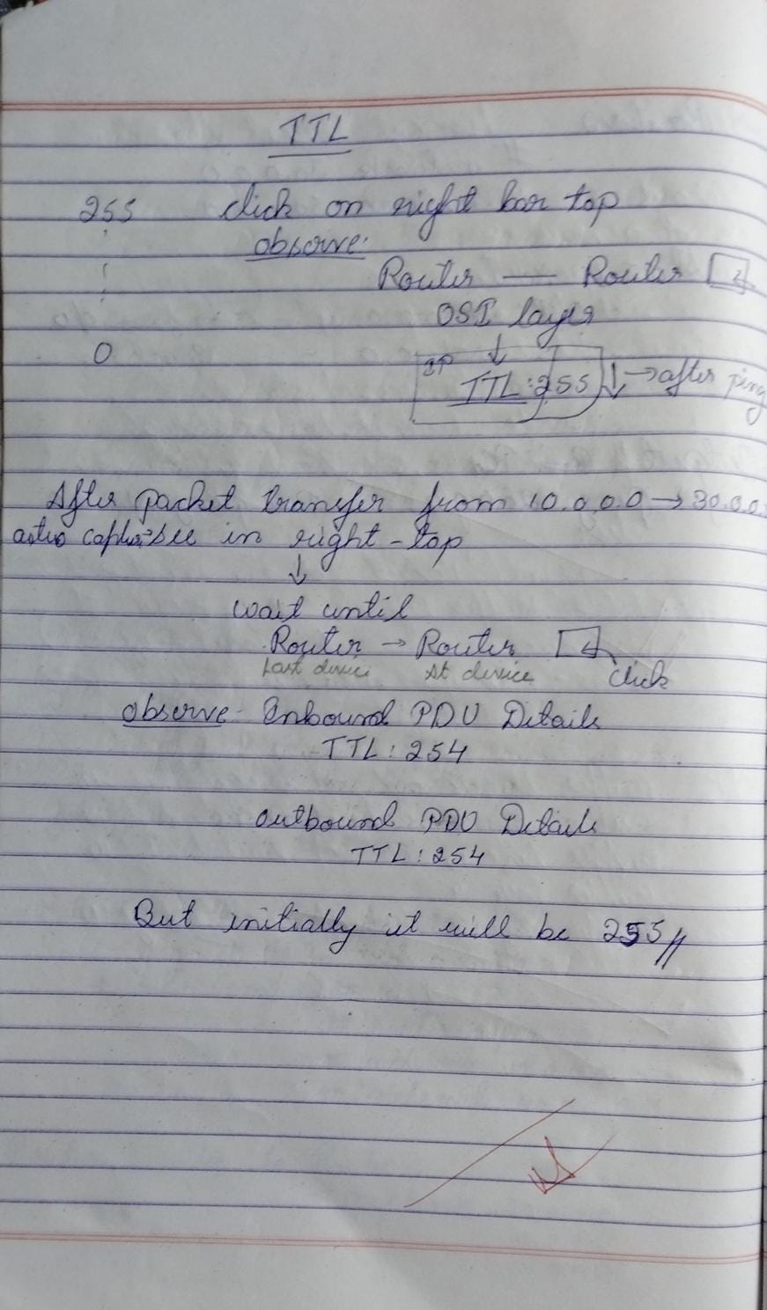Observation

## Program 8

1. Configure Web Server, DNS within a LAN.
2. Procedure along with the topology

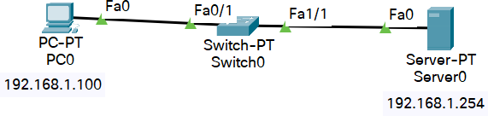

1. Screen shots/ output

Server’s services

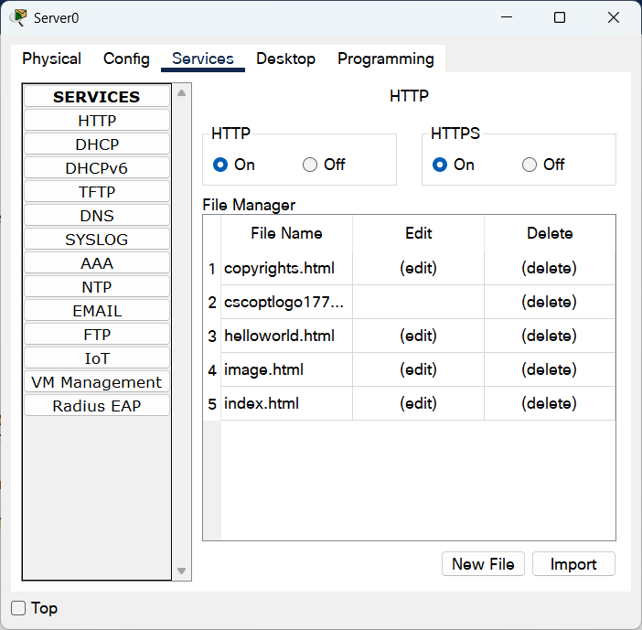

PC’s Web Browser

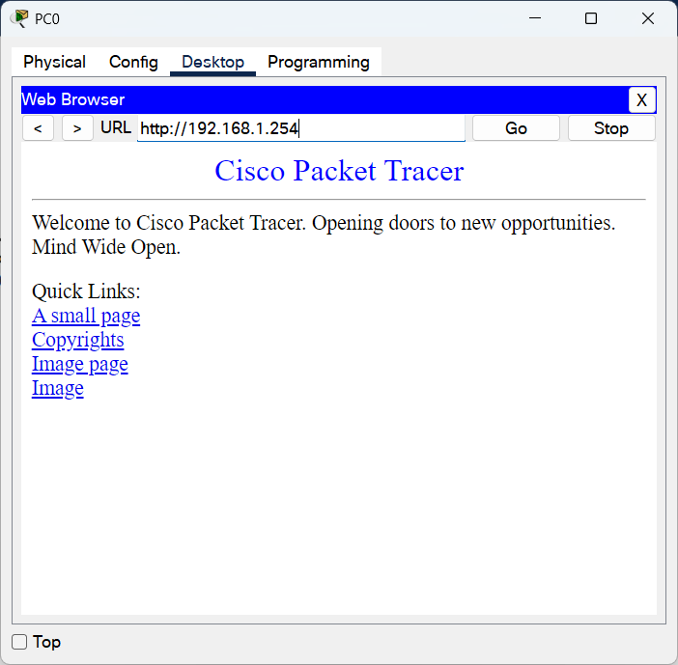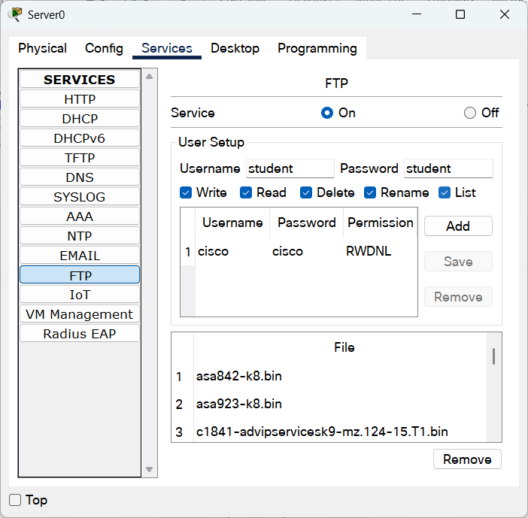

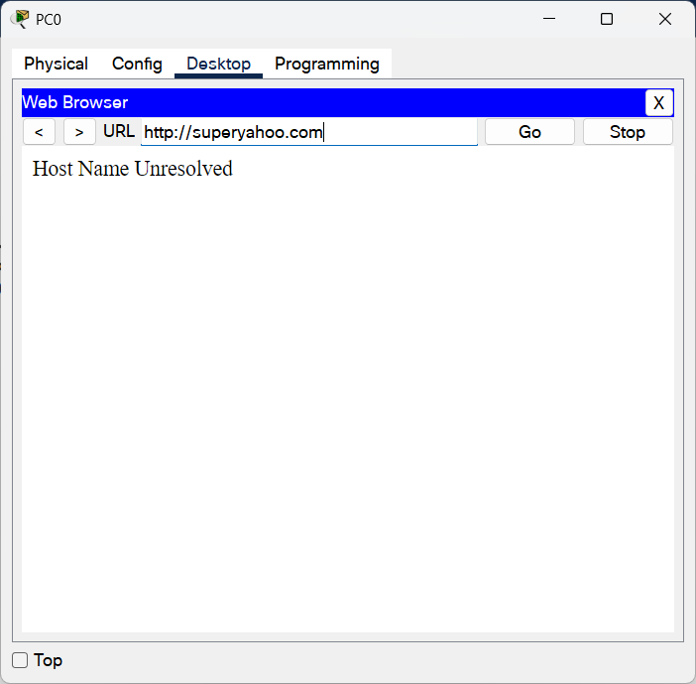

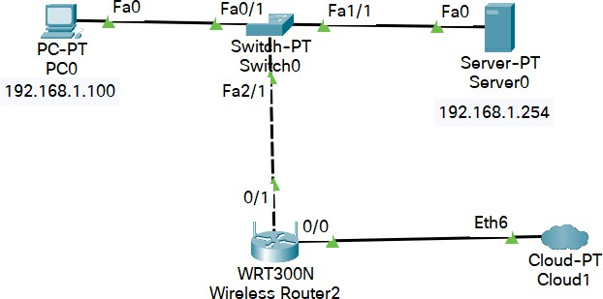

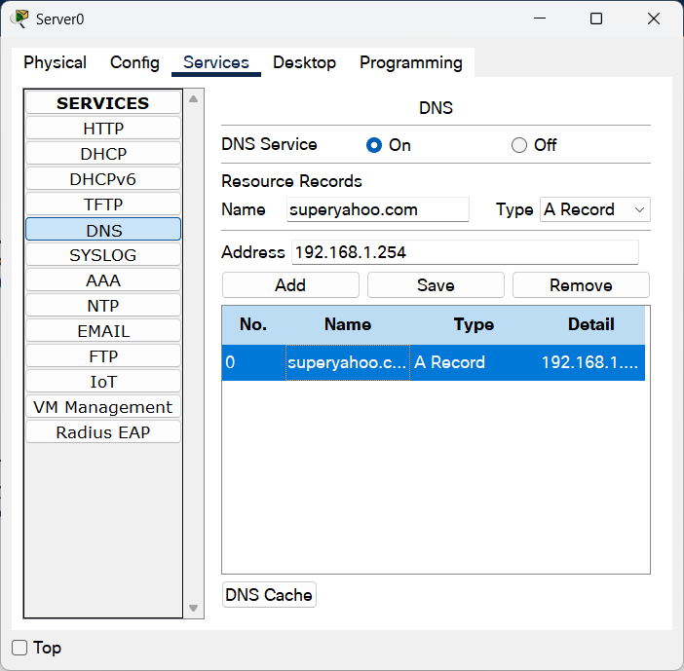

1. Observation

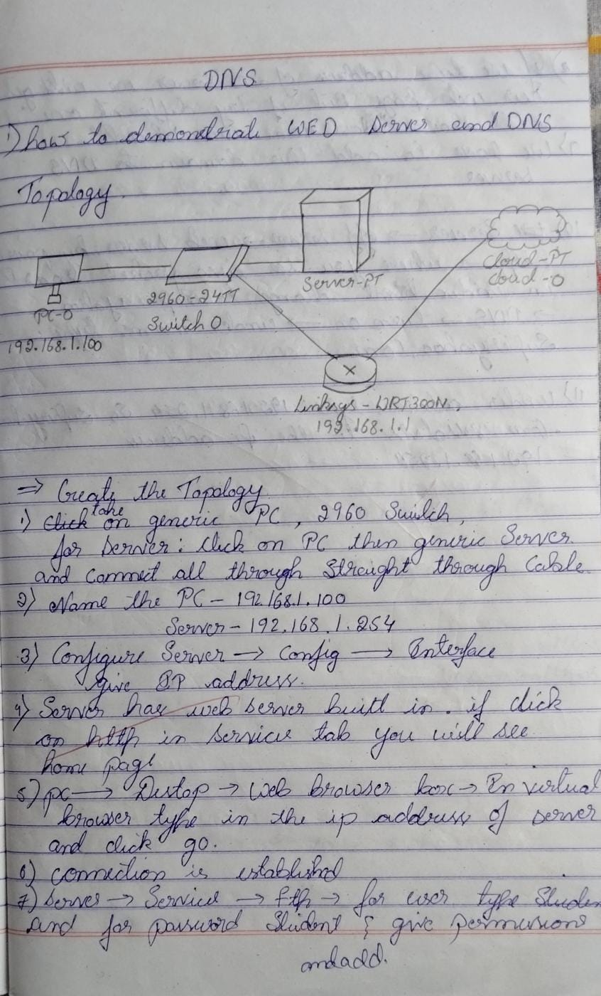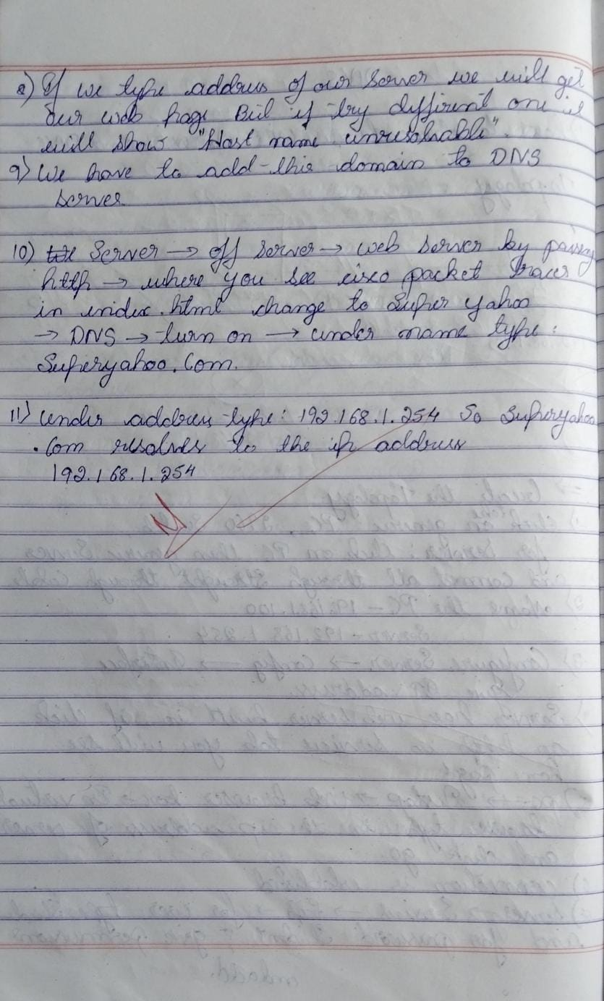

## Program 9

1. To construct simple LAN and understand the concept and operation of Address Resolution Protocol (ARP)
2. Procedure along with the topology

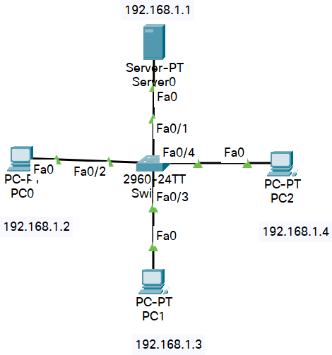

1. Screen shots/ output ARP Table of PC

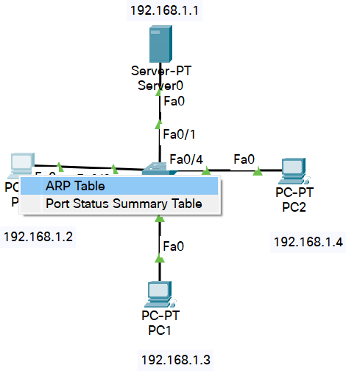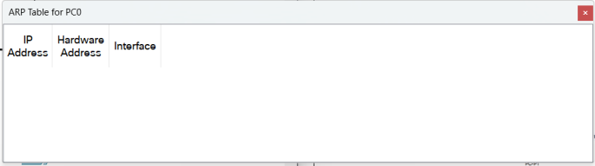

ARP Table of Server

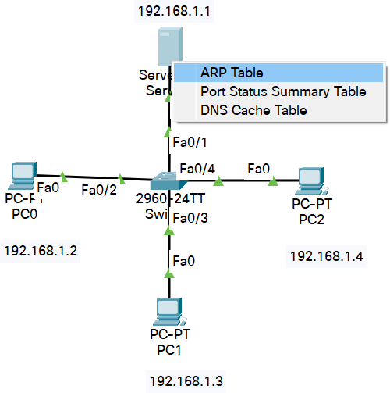 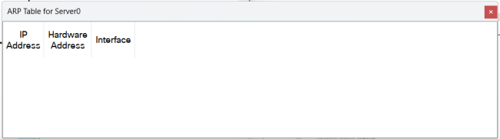

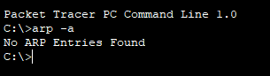Command at PC

Pinging in Simulation Mode

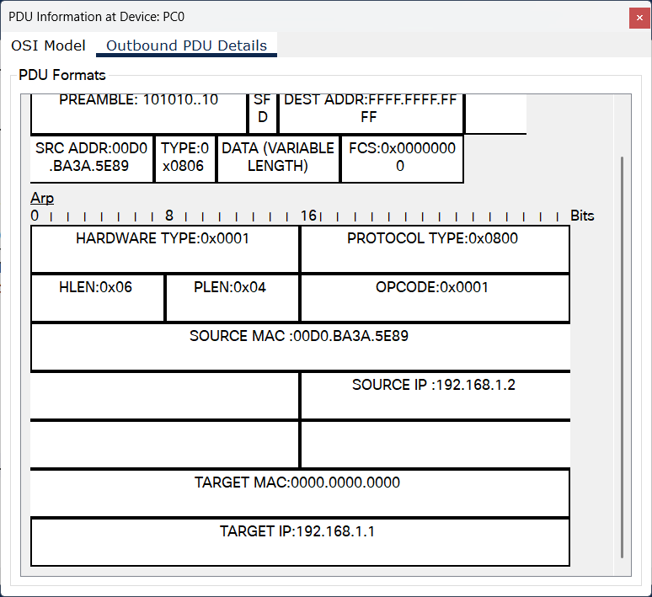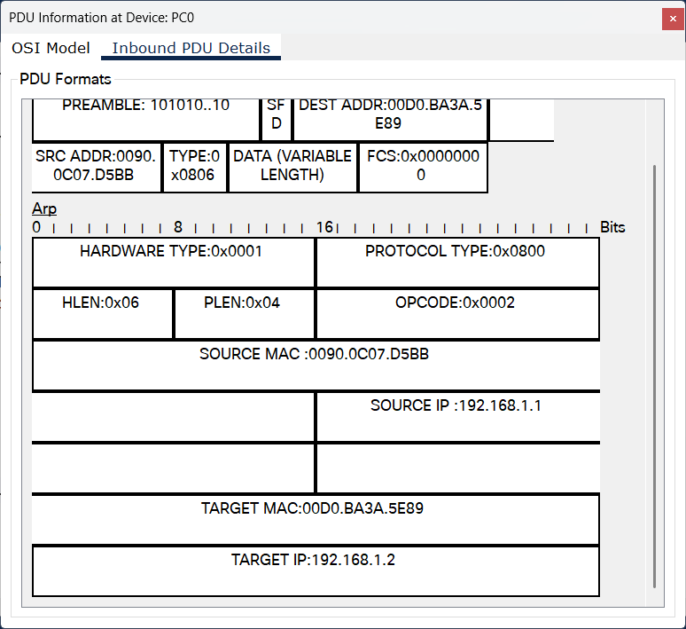

1. 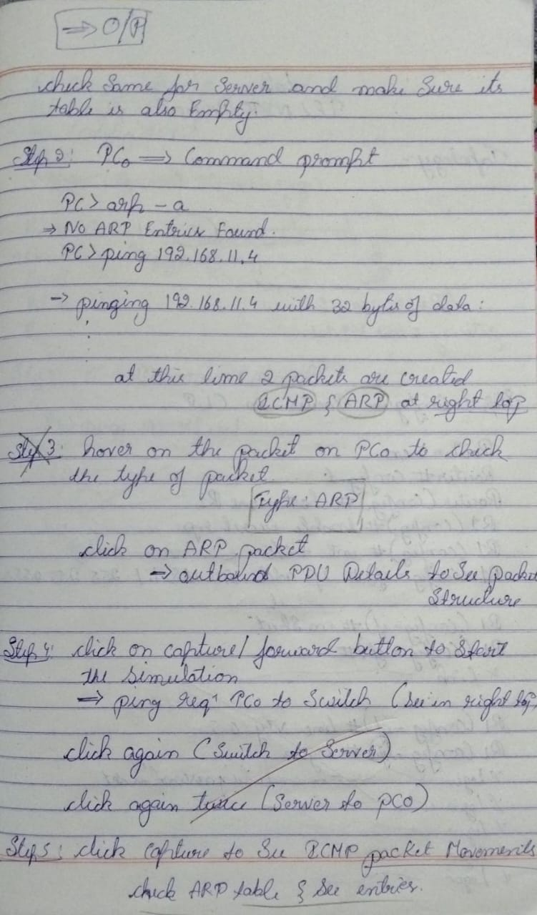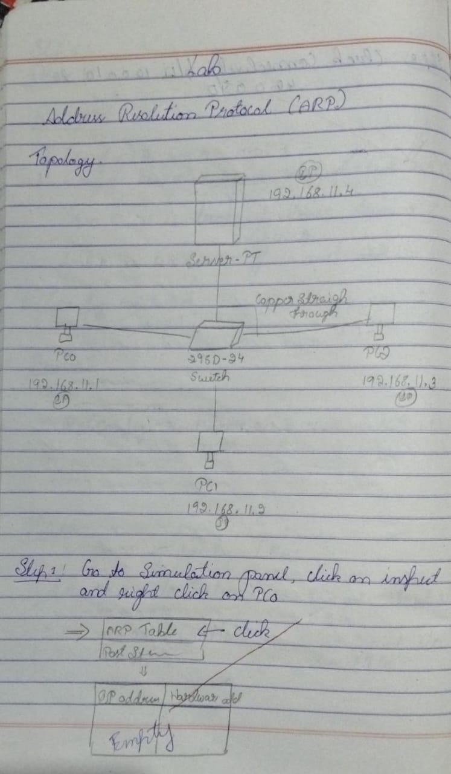Observation

## Program 10

1. To understand the operation of TELNET by accessing the router in server room from a PC in IT office.
2. Procedure along with the topology

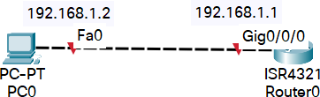

1. Screen shots/ output Router

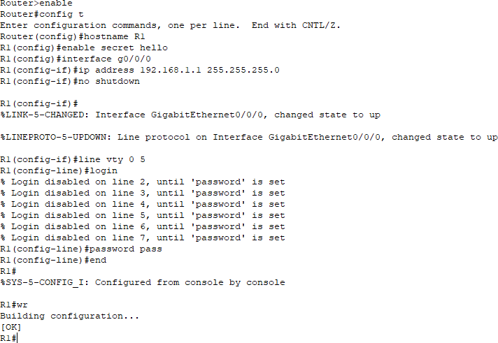

PC

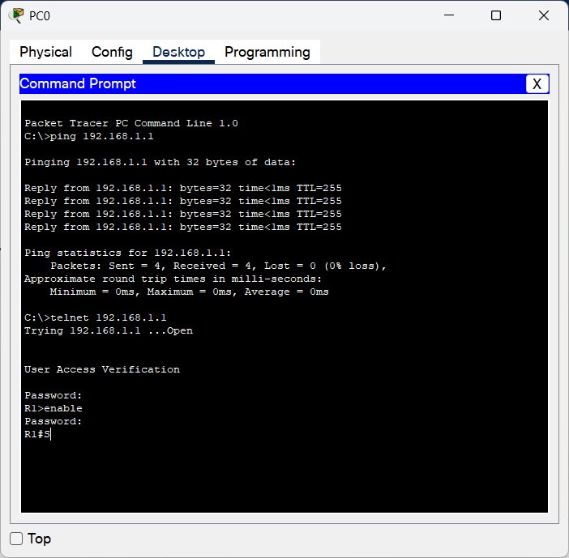

1. 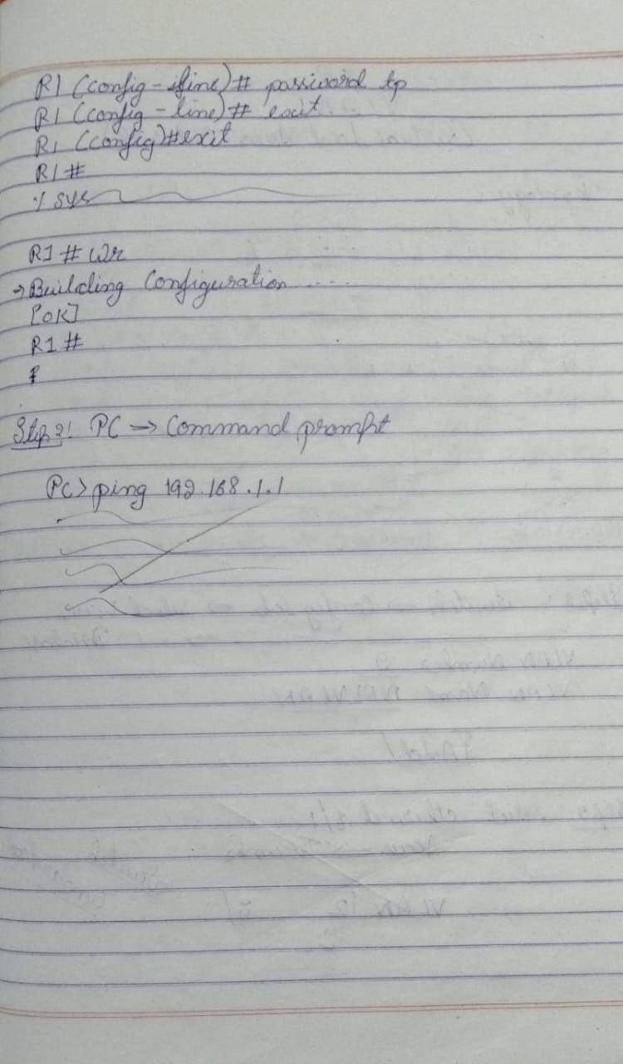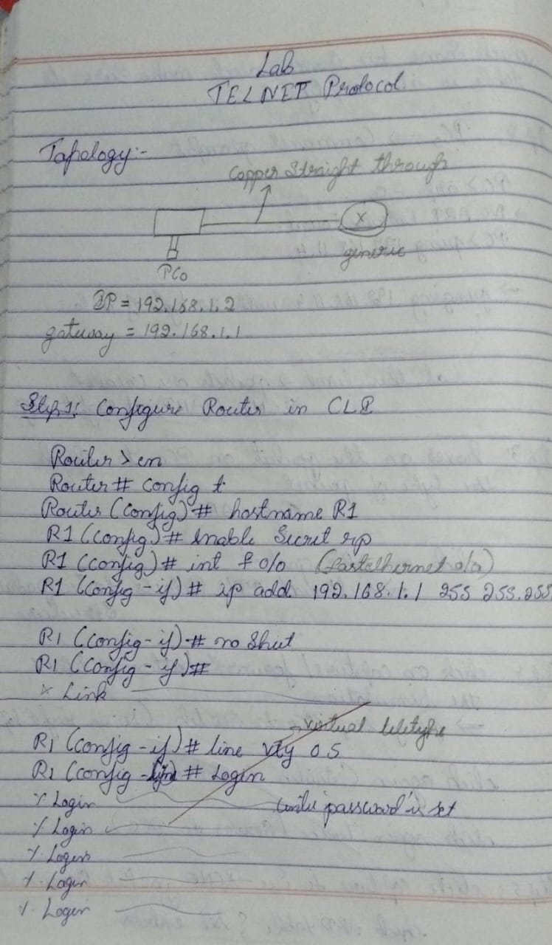Observation

## Program 11

1. To construct a VLAN and make the PC’s communicate among a VLAN
2. Procedure along with the topology

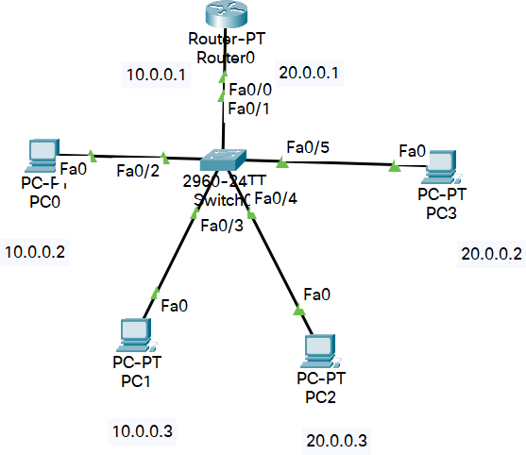

1. 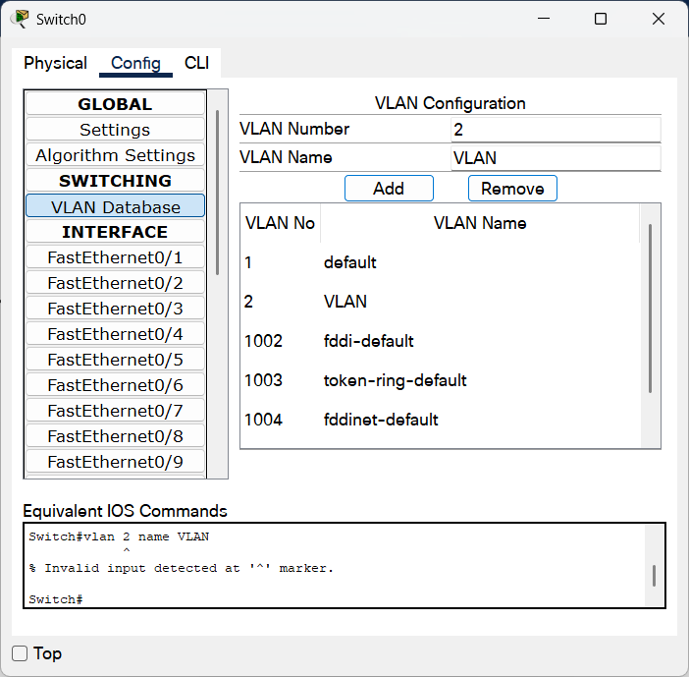Screen shots/ output Switch Configuration

Configuration of port connected to router

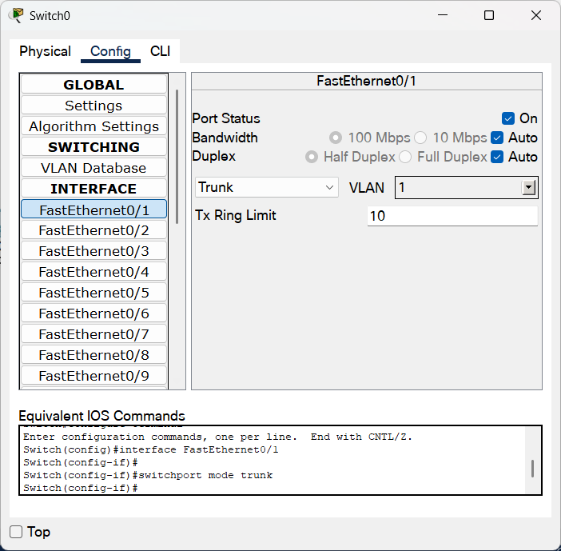

Configuration of ports connected to other networks

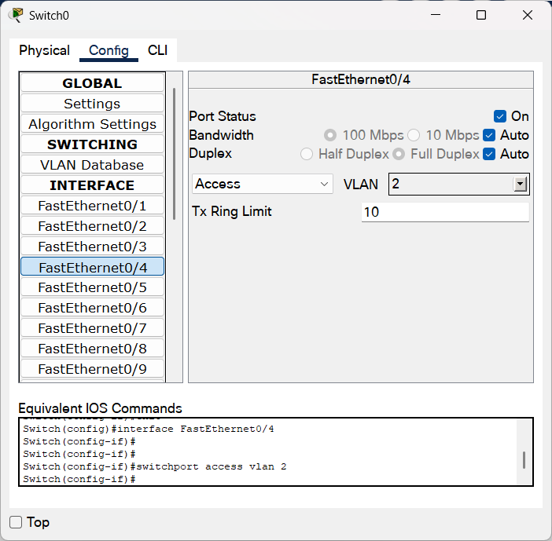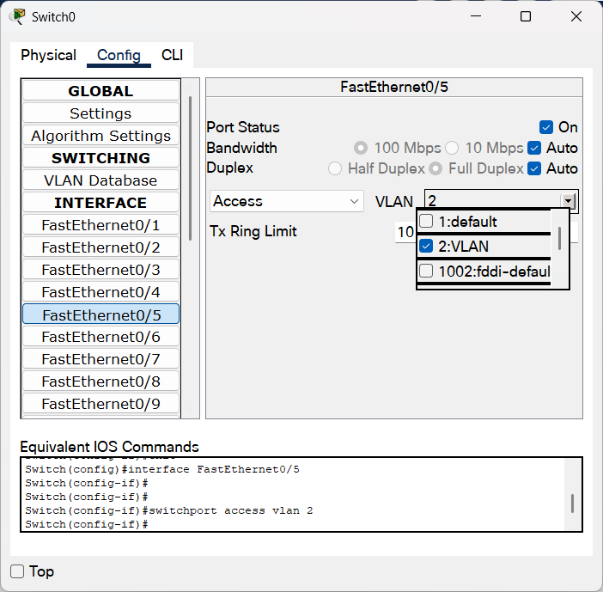

Configuartion of Router

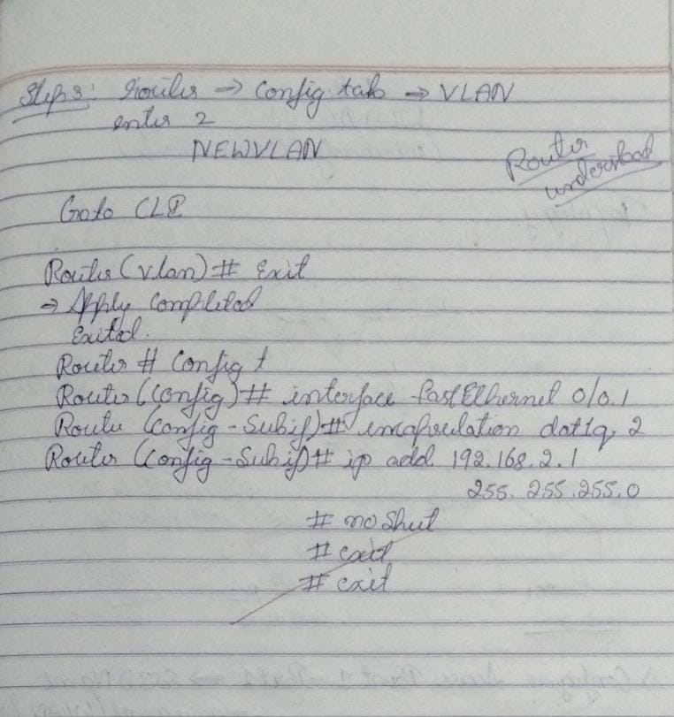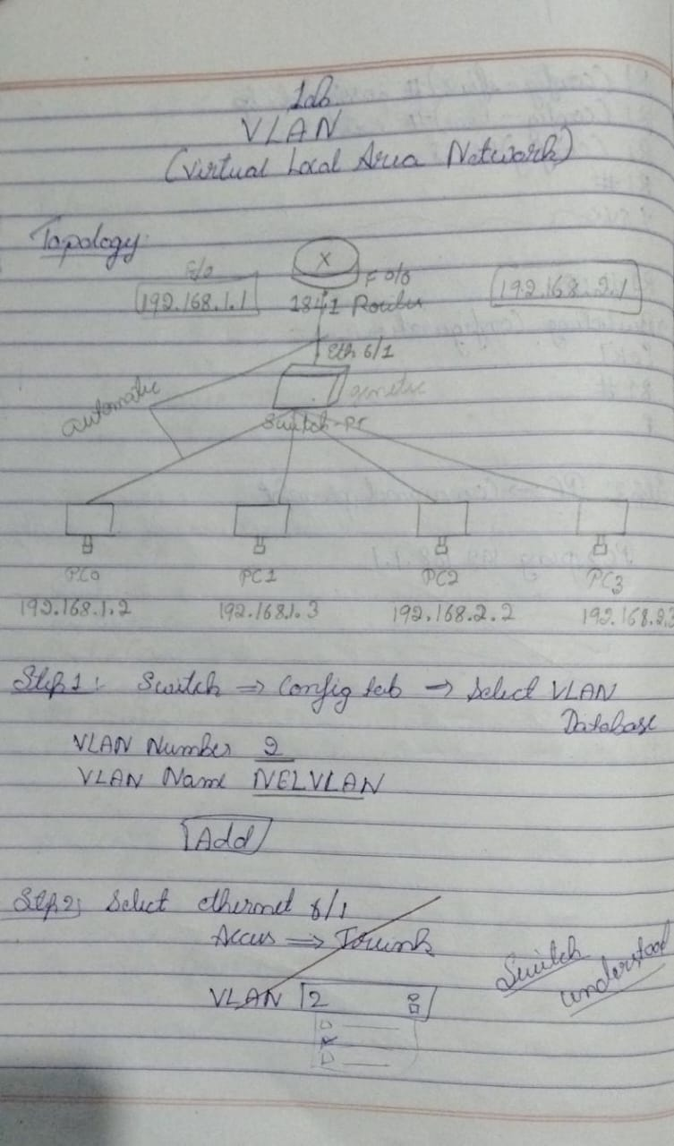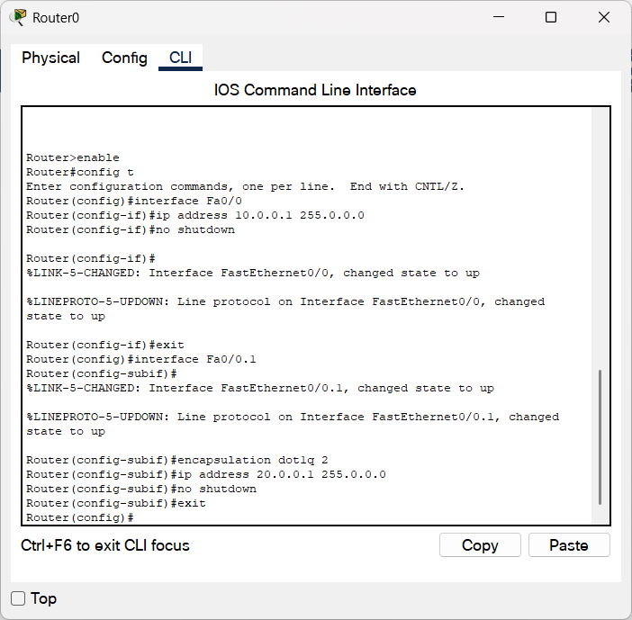

## Program 12

1. To construct a WLAN and make the nodes communicate wirelessly.
2. Procedure along with the topology

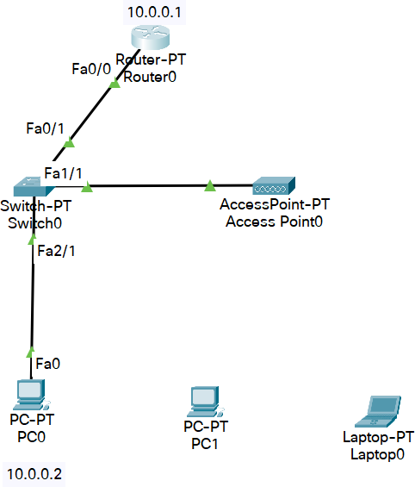

1. Screen shots/ output

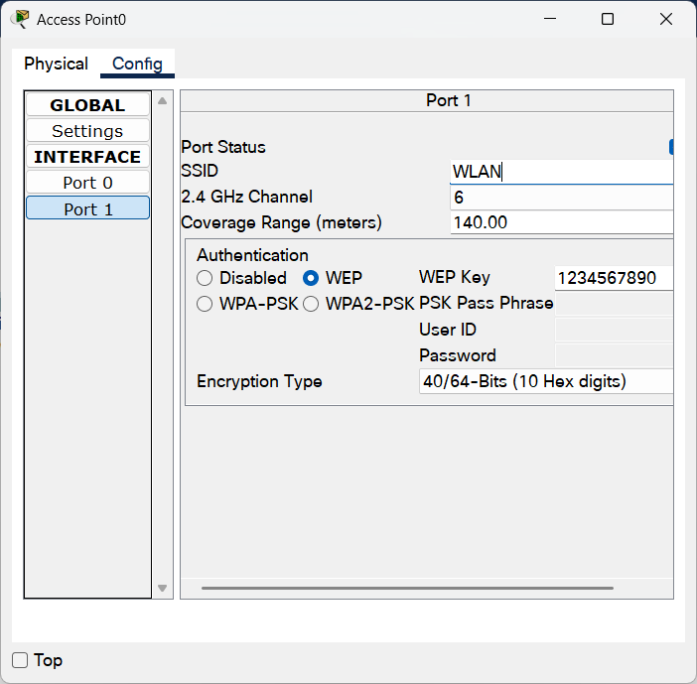

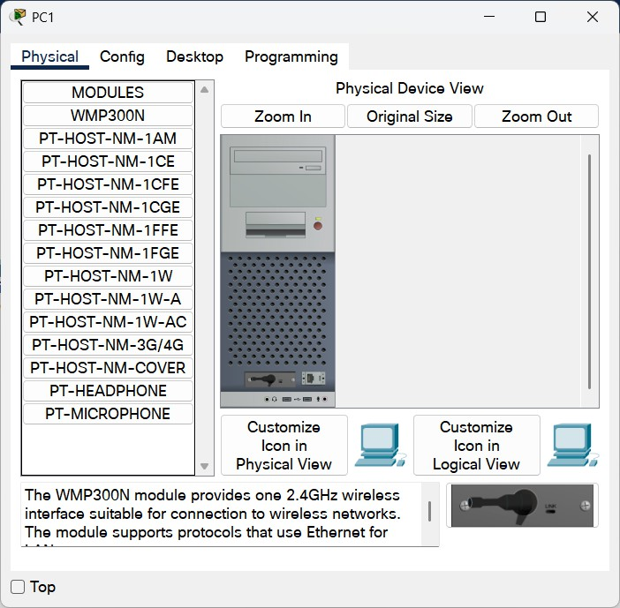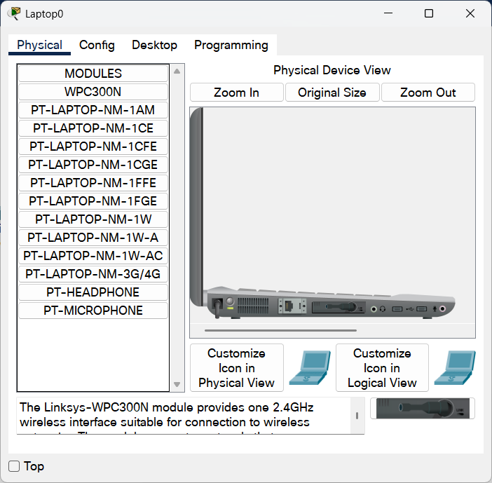

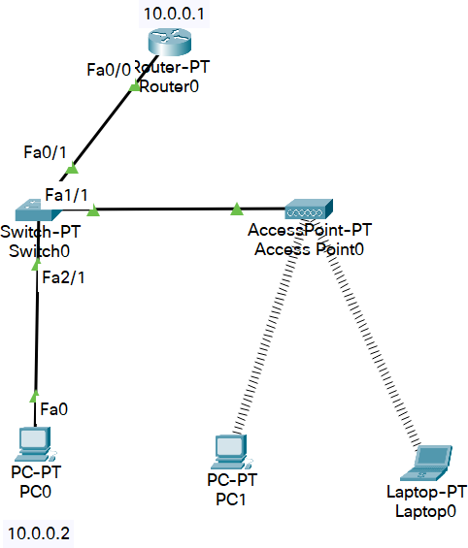

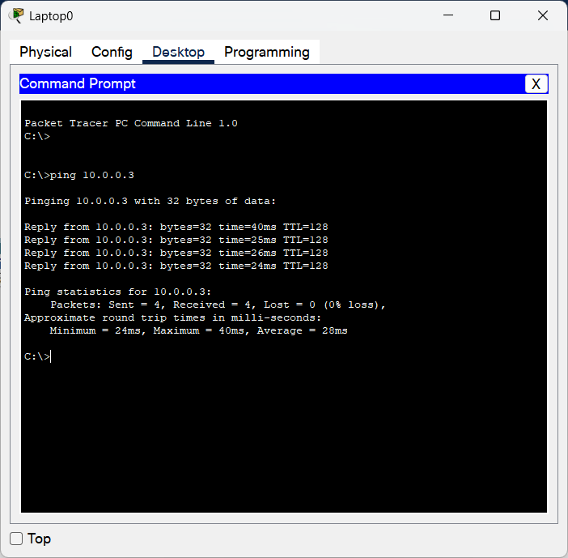Ping:

1. Observation

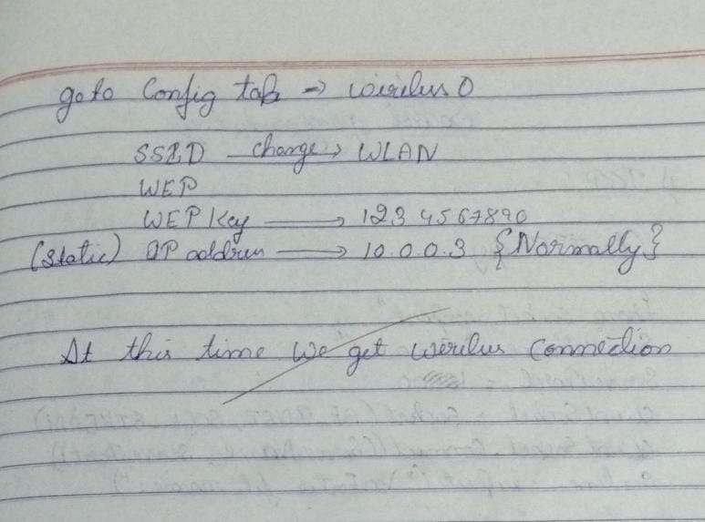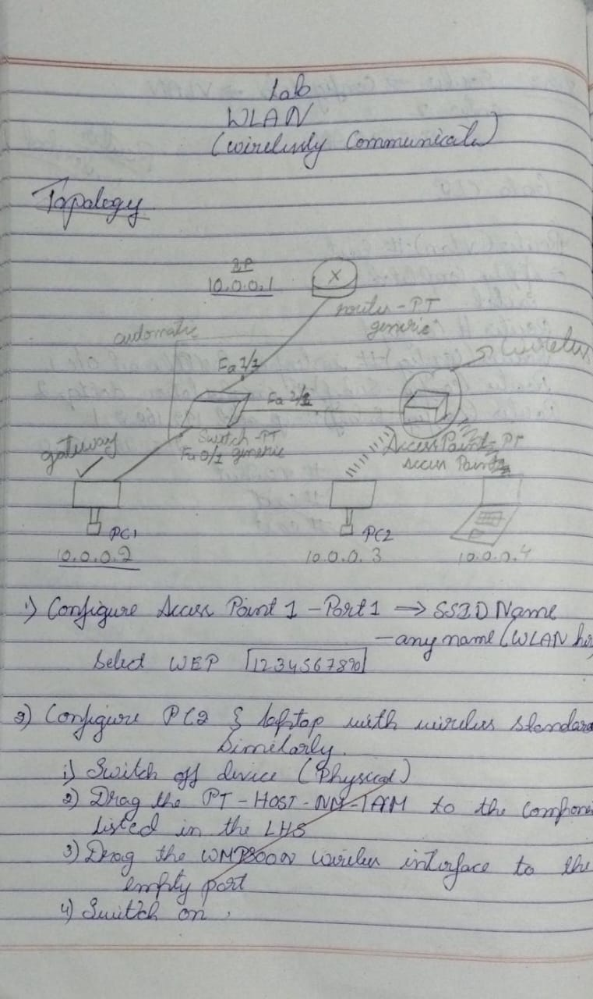

# Cycle-II

## Program 1

1. Write a program for error detecting code using CRC-CCITT (16-bits).
2. Procedure

def crc_ccitt_16_bitstream(bitstream: str, poly: int = 0x1021, init_crc: int = 0xFFFF) -> int: crc = init_crc

for bit in bitstream:

crc ^= int(bit) << 15 # Align the bit with CRC's uppermost bit for _ in range(1): # Process the single bit

if crc & 0x8000: # Check if the leftmost bit is set crc = (crc << 1) ^ poly

else:

crc <<= 1

crc &= 0xFFFF # Ensure CRC remains 16-bit return crc

def append_crc_to_bitstream(bitstream: str) -> str: crc = crc_ccitt_16_bitstream(bitstream)

crc_bits = f"{crc:016b}" # Convert CRC to a 16-bit binary string return bitstream + crc_bits

def verify_crc_bitstream(bitstream_with_crc: str) -> bool: if len(bitstream_with_crc) < 16:

return False # Not enough bits to contain CRC

data, received_crc = bitstream_with_crc[:-16], bitstream_with_crc[-16:] calculated_crc = crc_ccitt_16_bitstream(data)

return calculated_crc == int(received_crc, 2)

# Example usage:

if name == " main ":

# User input for original bitstream

message_bits = input("Enter the original bitstream (e.g., 11010011101100): ")

# Calculate and append CRC

bitstream_with_crc = append_crc_to_bitstream(message_bits) print(f"Bitstream with CRC: {bitstream_with_crc}")

# User input for verification user_bitstream = input(

"Enter the received bitstream for verification (e.g., 11010011101100110110110111000011): "

)

# Verify CRC

is_valid = verify_crc_bitstream(user_bitstream) print(f"CRC valid: {is_valid}")

1. Screen shots/ output

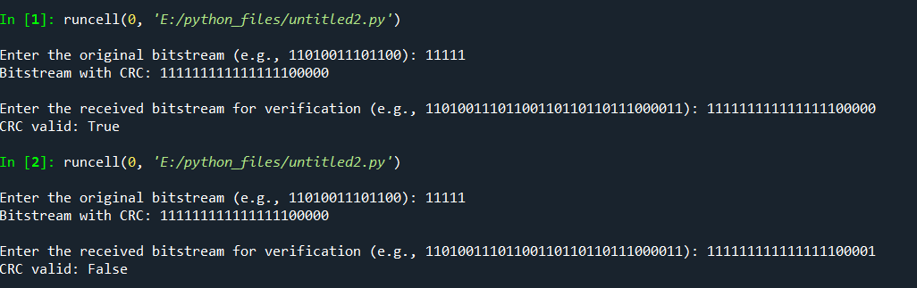

1. 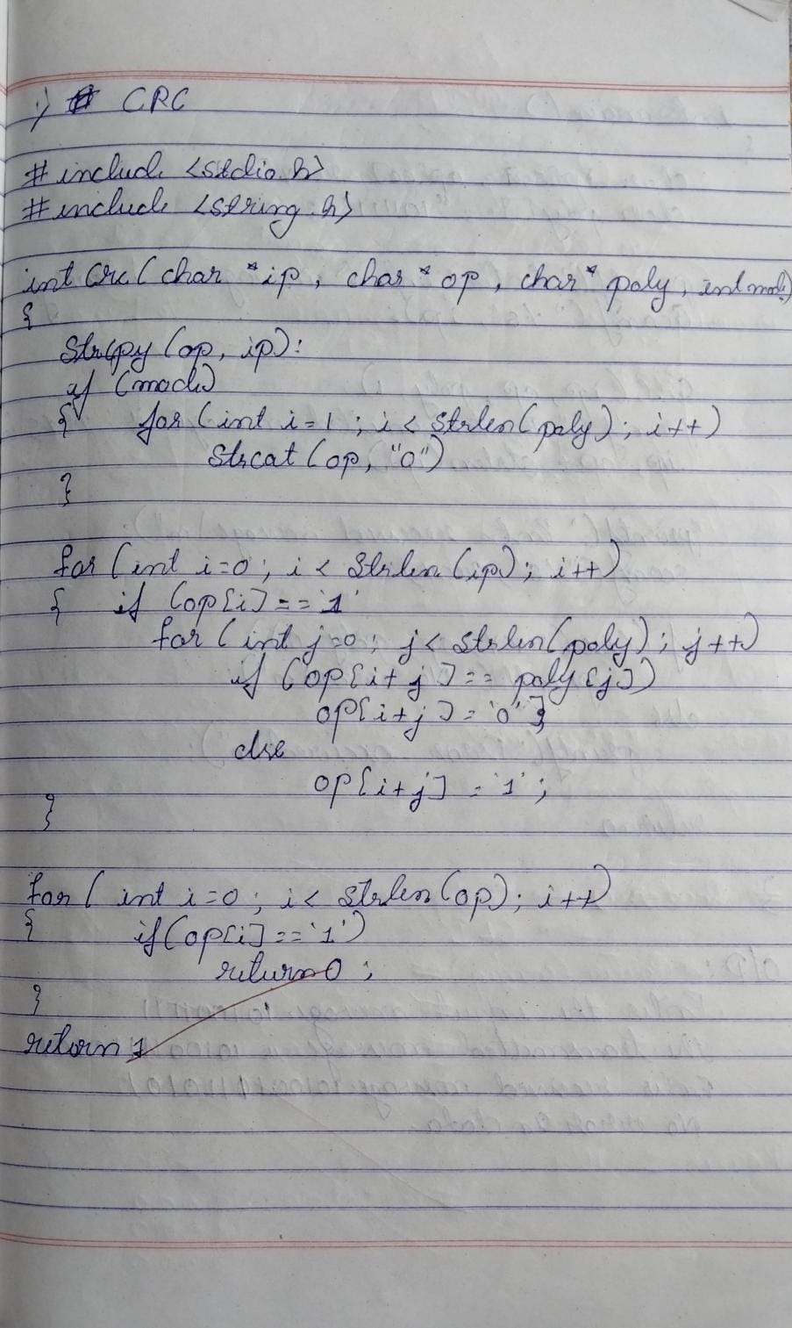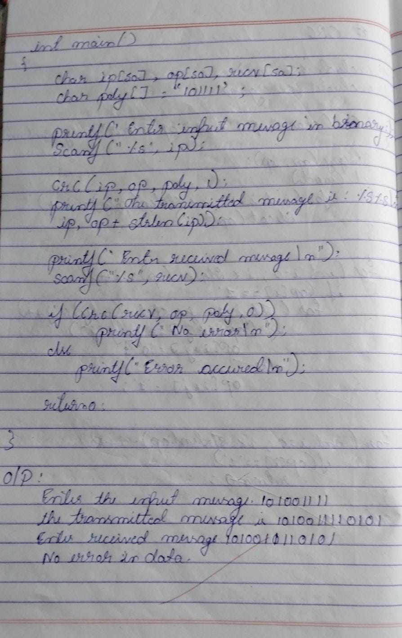Observation

## Program 2

1. Write a program for congestion control using Leaky bucket algorithm
2. Procedure def main():

# Initial packets in the bucket

storage = 0

# Total number of times bucket content is checked no_of_queries = 4

# Total number of packets that can be accommodated in the bucket bucket_size = 10

# Number of packets that enter the bucket at a time input_pkt_size = 4

# Number of packets that exit the bucket at a time output_pkt_size = 1

for _ in range(no_of_queries): # Space left in the bucket

size_left = bucket_size - storage

if input_pkt_size <= size_left: # Update storage

storage += input_pkt_size else:

print(f"Packet loss = {input_pkt_size}")

print(f"Buffer size = {storage} out of bucket size = {bucket_size}") # Remove packets from storage

storage -= output_pkt_size

if name == " main ": main()

1. Screen shots/ output

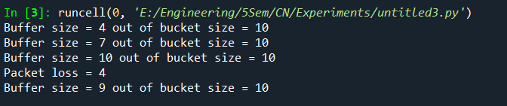

1. 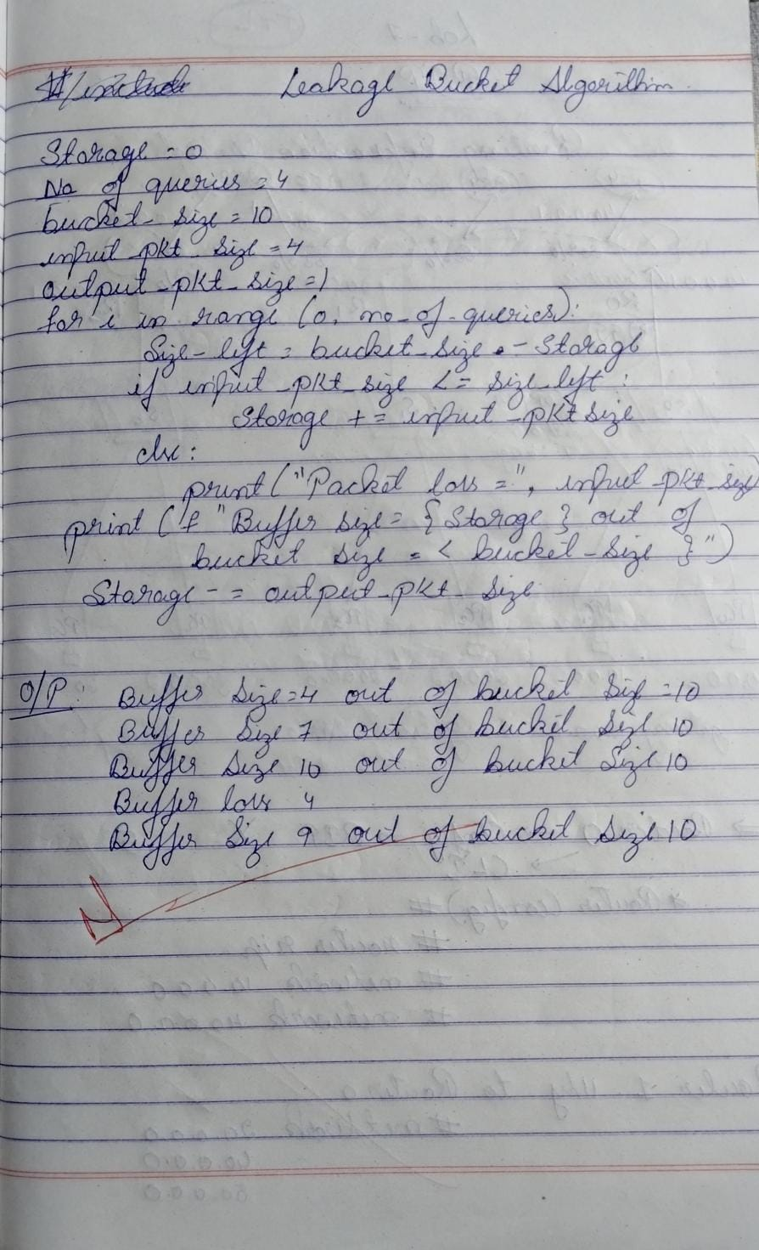Observation

## Program 3

1. Using TCP/IP sockets, write a client-server program to make client sending the file name and the server to send back the contents of the requested file if present.
2. Procedure clientTCP.py

from socket import *

serverName = '127.0.0.1'

serverPort = 12000

clientSocket = socket(AF_INET, SOCK_STREAM) clientSocket.connect((serverName,serverPort)) sentence = input("\nEnter file name: ")

clientSocket.send(sentence.encode()) filecontents = clientSocket.recv(1024).decode() print ('\nFrom Server:\n')

print(filecontents) clientSocket.close()

serverTCP.py

from socket import * serverName="127.0.0.1" serverPort = 12000

serverSocket = socket(AF_INET,SOCK_STREAM) serverSocket.bind((serverName,serverPort)) serverSocket.listen(1)

while 1:

print ("The server is ready to receive") connectionSocket, addr = serverSocket.accept() sentence = connectionSocket.recv(1024).decode()

file=open(sentence,"r") l=file.read(1024)

connectionSocket.send(l.encode()) print ('\nSent contents of ' + sentence) file.close()

connectionSocket.close()

1. Screen shots/ output Client

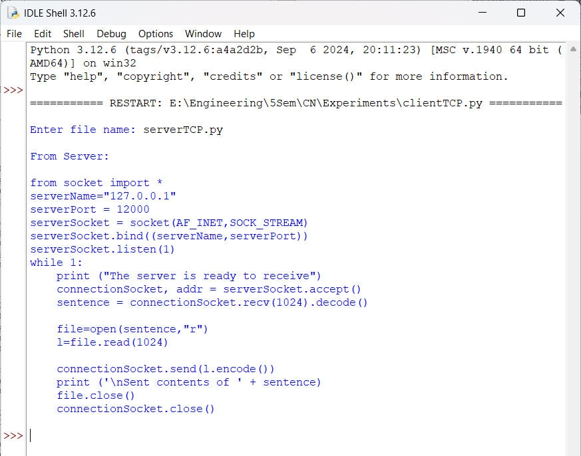

Server

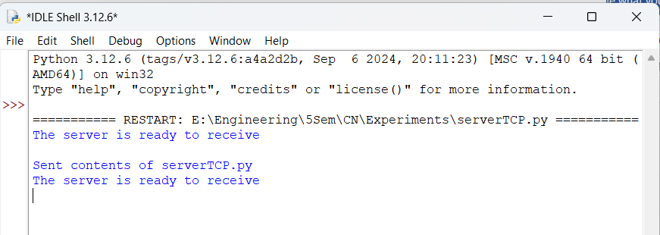

1. Observation

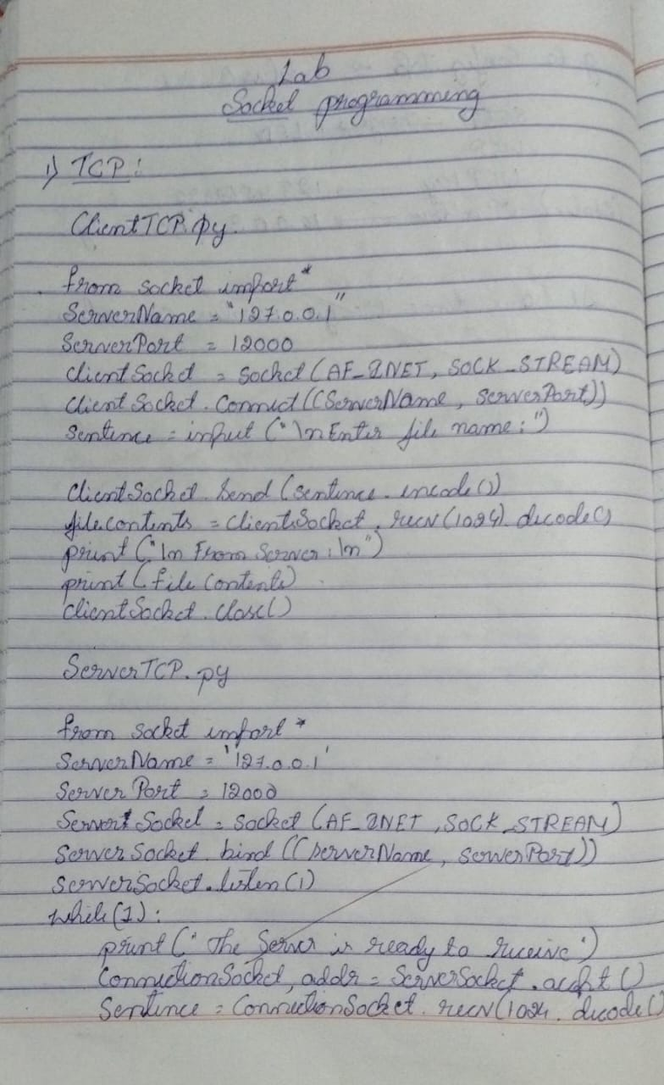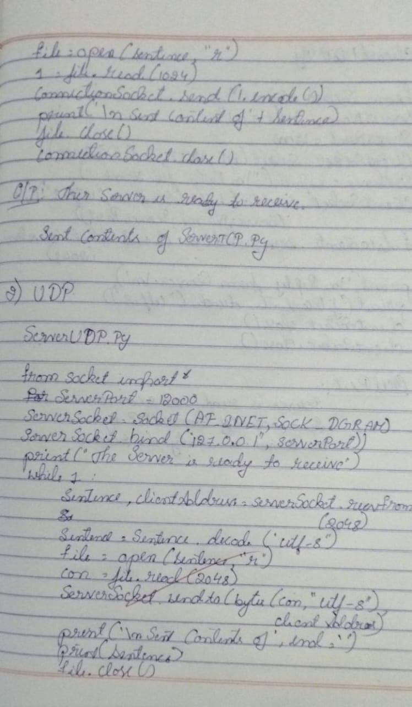

## Program 4

1. Using UDP sockets, write a client-server program to make client sending the file name and the server to send back the contents of the requested file if present.
2. Procedure clientUDP.py

from socket import *

serverName = "127.0.0.1"

serverPort = 12000

clientSocket = socket(AF_INET, SOCK_DGRAM) sentence = input("\nEnter file name: ")

clientSocket.sendto(bytes(sentence,"utf-8"),(serverName, serverPort))

filecontents,serverAddress = clientSocket.recvfrom(2048) print ('\nReply from Server:\n')

print (filecontents.decode("utf-8")) # for i in filecontents:

# print(str(i), end = '') clientSocket.close() clientSocket.close()

serverUDP.py

from socket import * serverPort = 12000

serverSocket = socket(AF_INET, SOCK_DGRAM) serverSocket.bind(("127.0.0.1", serverPort))

print ("The server is ready to receive") while 1:

sentence, clientAddress = serverSocket.recvfrom(2048) sentence = sentence.decode("utf-8") file=open(sentence,"r")

con=file.read(2048)

serverSocket.sendto(bytes(con,"utf-8"),clientAddress) print ('\nSent contents of ', end = ' ')

print (sentence)

# for i in sentence:

# print (str(i), end = '') file.close()

1. Screen shots/ output Client

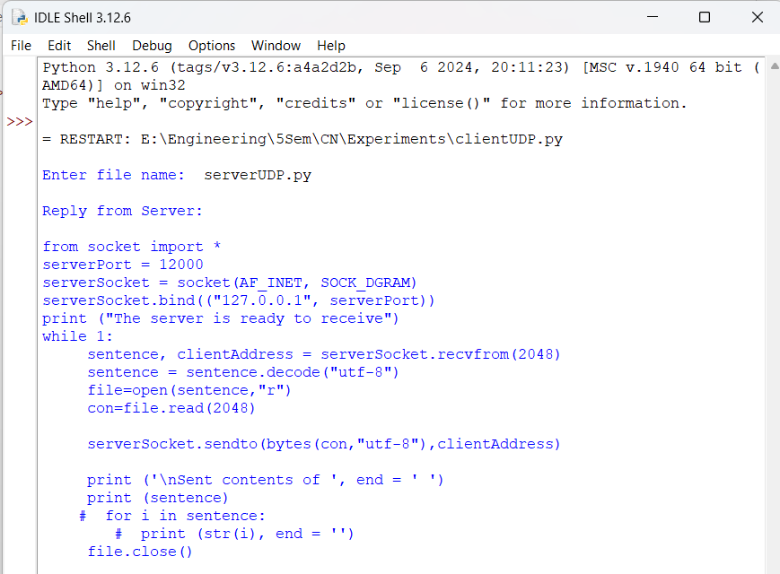

Server

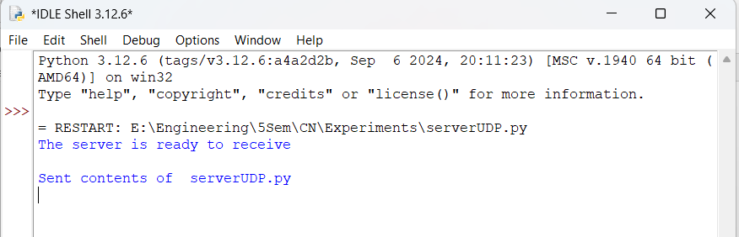

1. Observation

